Applying the CSM-CERES-Maize for agricultural zoning of climate risk in Brazil

Tales Antônio Amaral¹; Camilo de Lelis Teixeira de Andrade¹; Santiago Vianna Cuadra²; José Eduardo B. A. Monteiro²; Paulo Evaristo de O. Guimarães¹ e Roberto dos Santos Trindade¹

¹ Embrapa Milho e Sorgo, Rodovia MG 424 Km 45, Esmeraldas II, C.P 151, 35701-970 - Sete Lagoas, MG, Brazil. Emails: tales_aamaral@yahoo.com.br, camilo.andrade@embrapa.br, paulo.guimaraes@embrapa.br e roberto.trindade@embrapa.br
² Embrapa Digital Agriculture, UNICAMP/Embrapa, Av. Dr. André Tosello, 209, Cidade Universitária, 13083-886 - Campinas, SP, Brazil. Emails: santiago.cuadra@embrapa.br e eduardo.monteiro@embrapa.br

ABSTRACT
Water deficit is the main factor that limits maize yield in Brazil. This study was carried out with the objective of developing a methodology for applying a model based on biophysical processes, in the agricultural zoning of climate risk for maize crop. The CSM-CERES-Maize model, from the platform Decision Support System for Agrotechnology Transfer – DSSAT, was applied to perform the simulations. Maize genotype data, obtained in cultivar registration trials (VCU), carried out in different regions of the country, were used to parameterize and evaluate the predictive capacity of the model. Subsequently, the model, along with soil and climate data from across the country, was used to simulate maize yield for scenarios of 36 sowing dates through the year, soils with six levels of available water and cultivars with three cycle durations. For sowings in the first cropping season, the planting periods are similar between the risk map obtained with ZarcPro and that obtained with traditional Zarc. When planting in the second season (offseason) and with yields of 1000 or 2000 kg ha⁻¹, planting periods are longer in ZarcPro than in Zarc, with the opposite situation for yields of 6000 kg ha⁻¹ or greater. More similar planting periods are found for yield ranging from 3000 to 4000 kg ha⁻¹.
Keywords:
Modeling, DSSAT; ZarcPro-Maize; Zea mays L.

Aplicação do modelo CSM-CERES-Maize no zoneamento de risco climático no Brasil

RESUMO
O déficit hídrico é o principal fator que limita a produtividade de milho no Brasil. Realizou-se este estudo com o objetivo de desenvolver uma metodologia para aplicação de um modelo baseado em processos biofísicos, no zoneamento agrícola de risco climático da cultura do milho. Empregou-se o modelo CSM-CERES-Maize, da plataforma de simulação Decision Support System for Agrotechnology Transfer - DSSAT. Dados de genótipos de milho, obtidos em ensaios de registro de cultivares (VCU), conduzidos em diferentes regiões do país, foram utilizados para parametrizar e avaliar a capacidade preditiva do modelo. Posteriormente, o modelo, juntamente com dados de solos e de clima de todo o país, foi empregado para simular a produtividade de milho para cenários de 36 datas de semeadura ao longo do ano, solos com seis níveis de água disponível e cultivares com três durações de ciclo. Para semeaduras na primeira safra, as janelas de plantio são similares entre o mapa de risco obtido com o ZarcPro e o obtido com o Zarc tradicional. No plantio na segunda safra e com rendimentos de 1000 ou 2000 kg ha⁻¹, os períodos de plantio são maiores no ZarcPro do que no Zarc, com situação inversa em produtividades de 6000 kg ha⁻¹ ou maiores. Constata-se períodos de plantio mais semelhantes no intervalo de produtividades entre 3000 e 4000 kg ha⁻¹.
Palavras-chave:
Modelagem; DSSAT; ZarcPro-Milho; Zea mays L.

Introduction

The area planted with maize in Brazil, in the 2020/2021 harvest season, increased 7.2% compared to the previous season. However, production in the two main harvest seasons reduced by 15.1%, due to the drought, which occurred at crucial periods of the crop cycles, and also due to frosts that occurred in the main producing states in the Center-South region of the country. In the second season (offseason), the area increased 9%, approaching 15 million hectares, while production was 60.7 million tons, with an average yield just above 4 t ha⁻¹. In the state of Mato Grosso, the largest national producer in the offseason, it was found that around 60% of maize crops sown in the ideal planting window achieved excellent performance, driven by the growing investments applied to the crop. On the other hand, the remaining cropping, sown outside the ideal window, faced different degrees of water stress due to the drought, which generated yield diversity, leading to an overall reduction of 12% in the state's productivity (Anuário brasileiro do milho, 2022).
The growth and development period of maize is limited by soil-water, air temperature and solar radiation or luminosity. The crop needs some indices related to these elements to reach optimal conditions so that it can express its yield potential (Mantovani et al., 2015). Among the factors that most limit maize yield, water deficit is the main one, which can cause losses of around 50%. In Brazil, maize crop is predominantly carried out under rainfed conditions, and is therefore subject to possible water stress resulting from instabilities in the rainfall regime. Water deficit affects practically all aspects related to plant development, reducing leaf area and photosynthesis, and interfering with several other processes (Bergamaschi, 1992). The greatest reduction in production occurs as a result of water deficit during the periods that include pollination, zygote formation and initial grain development (Bergamaschi et al., 2006).
Considering that the photoperiod effect on development of tropical maize cultivars is null or minimal, it is the temperature/heat conditions that have a significant influence on the duration of the cycle and on the grain yield of this cereal (Rehagro, 2022). The thermal sum or degree-days, based on energy accumulation above a certain base temperature, is generally used in models that describe the phenological development and growth of maize. Within the same maturation group, it is possible to estimate the occurrence of crop phases, for different genotypes, regions and growing seasons, using air temperature as the only variable (Bergamaschi & Matzenauer, 2009). Berlato & Sutili (1978) obtained, as the best minimum basal temperatures, 4 °C for early hybrids, 6 °C for medium cycle ones, and 8 °C for late ones, according to the classification adopted at the time. However, Kiniry (1991) considered 8 °C and 44 °C as extreme limits for maize phenology, with maximum growth occurring between 26 °C and 34 °C. For several genotypes from Australia, Birch et al. (1998) adopted the following cardinal temperatures to calculate degree days: Lower Tb of 8 ºC, optimum Tb of 30 °C and upper Tb of 40 °C.
The occurrence of frost, especially at the end of winter and beginning of spring, is a likely risk, especially in the South, Southeast and part of the Central-West regions of Brazil. As long as the plants' growing point is below the soil surface (up to around three fully developed leaves, V3), frost, hail and windstorms have little or no effect on the final crop yield. In V6, frosts are more damaging, as are hail and windstorms, as the plants have their growing point above ground level (Ritchie et al., 1993). Floods can occur, but in specific areas that favor this phenomenon. However, excessive rainfall during crop establishment or harvesting can cause considerable damage.
During flowering, the combination of water deficit and high daytime temperatures affect pollination and initial grain formation, resulting in a decrease in the number of grains per ear. Hot nights during this stage can also reduce grain number, affecting grain survival and grain early development (Ritchie et al., 1993; Nielsen, 2005). On the other hand, high temperatures, especially at night, can reduce the net assimilation of plants, due to increased losses through respiration. Brunini et al. (2006) also observed that high night temperatures can harm crop development, although choosing appropriate sowing times can avoid such conditions, including mitigating thermal stress in the daytime period, during flowering.
Solar radiation is the main factor related to maize yield. Any other factor that affects the leaf area index and, consequently, the interception of photosynthetically active radiation, will also affect crop productivity. Among them, stand out the water and nitrogen deficit in the soil, the density and arrangement of plants in the area (Bergamaschi & Matzenauer, 2009).
A practically cost-free strategy to mitigate the possible deleterious effects of climatic conditions, such as frost and water stress, among others, especially in the offseason, is sowing at the right time. Agricultural Climate Risk Zoning (Zarc) is a tool used today in Brazil that allows, based on knowledge of local weather conditions, type of soil and cultivar used, to define sowing windows that reduce the risk of crop yield loss, including maize (Brazil, 2022). However, in its current format, Zarc does not allow the estimation of expected yield (EY), which limits some decision making by producers, insurance companies, institutions that offer credit and government agencies.
An alternative to including yield classes in Zarc is the use of crop growth models, such as CSM-CERES-Maize, belonging to the Decision Support System for Agrotechnology Transfer (DSSAT) (Jones et al., 2003; Hoogenboom et al., 2019).
The objective of this study was to develop a methodology for applying a model, based on biophysical processes, in the Agricultural Zoning of Climate Risk of Yield (ZarcPro), for maize crop.

Material and methods

The process-based model, CSM-CERES-Maize, from the simulation platform DSSAT - Decision Support System for Agrotechnology Transfer - was used in this study (Jones et al., 2003; Hoogenboom et al., 2019). In order to parameterize and evaluate the model, data on maize management, phenology and yield, obtained from trials required to register cultivars, named VCU trials, conducted in different seasons and locations in the country, were organized and compiled. Part of the data was used to parameterize the model and the remaining was applied to evaluate its predictive capacity. To run the simulations used in the crop zoning, historical series of daily weather data, obtained from different bases or sources, were organized and compiled, as well as, soil data from across the country.
After the parameterization and evaluation process, the CSM-CERES-Maize model was used to simulate maize yield for the entire national territory, and the historical series of simulated yield were processed for the different ZarcPro scenarios. At this phase, soil profiles, divided into six classes of available water (Teixeira et al., 2021), and climate series from 34 years of historical data were considered. The simulations are representative of the management of a typical, high-yield maize crop, taking into account decision criteria, such as soil moisture at sowing and the effect of frost on the crop. Maps and tables were generated and evaluated.

Description of the model
The model used in ZarcPro-Milho is the CSM-CERES-Maize, from the Decision Support System for Agrotechnology Transfer (DSSAT) platform, which has been developed and improved for more than 36 years and covers 42 crops (Hoogenboom et al., 2019). The DSSAT package includes a database of weather, soil and experimental crop results, as well as tools and interfaces that facilitate the addition of new data and the comparison of simulated with observed results.
The CSM-CERES-Maize model simulates the growth, development and yield of maize, depending on the dynamics of the soil-plant-atmosphere system. As input, the model requires daily weather data, soil surface and profile information, and crop management details, as well as initialization information and its rules. The simulations are started at or before planting, establishing a sufficient fallow period so that the management conditions in the model come close to real conditions. The calculations and variable value updates take one day. At the end of each day, the water, nitrogen, phosphorus and carbon balances are updated, as well as the vegetative and reproductive development stages of the crop.
In the case of maize grown in a tropical environment, the duration of the phenological phases, in days, depends exclusively on the air temperature, through a thermal sum system, expressed in degree days. Each phase or stage of crop development, from sowing to physiological maturity, requires a certain value of degree days to be completed (parameters P1 and P5 of the CSM-CERES-Maize model). Likewise, the number of leaves is defined by a parameter that corresponds to the thermal sum required to release subsequent leaves (model PHINT parameter). Therefore, the duration of the maize cycle and the number of leaves depend on the interaction between the cultivar and climatic conditions. Other model parameters are related to the number of grains per unit of planting area (parameter G1) and the unit weight of grains (parameter G3). Obtaining the values of these parameters depends on real data, collected in experiments or crop fields, carried out under optimal conditions, and an adjustment procedure called parameterization or calibration. Parameter values are specific to each cultivar.
In all simulations performed in the processes of model parameterization, evaluation and application, the P2 coefficient (the extent to which development, expressed in days, is delayed for each hour of increase in photoperiod above the longest photoperiod in which development proceeds at a maximum rate, which is considered 12.5 hours) and PHINT (phyllochron interval, which is the interval in thermal sum, degree-days, between successive appearances of leaf tips) assumed fixed values of 0.5 days and 45.5 degree-day, respectively.
At the end of the simulation, the model provides a series of files with detailed data on crop growth, development and yield, covering values of dozens of variables, on a daily basis, accumulated throughout the cycle, or at specific points in the cycle, allowing, thus, a complete analysis of the agronomic and biophysical performance of the crop.

Weather database
The climate database used in ZarcPro is made up of historical series obtained from the networks of meteorological and rainfall stations, conventional and automatic, from institutions, such as the National Institute of Meteorology (Inmet), the HidroWeb system, operated by the National Water Agency (ANA) and the Center for Weather Forecasting and Climate Studies (CPTEC/INPE), in addition to state networks maintained by public institutions or companies. Data on maximum temperature (TMax), minimum temperature (TMin), incident solar radiation (SRAD) and rainfall (RAIN) were analyzed, consisted and interpolated into a grid covering the entire country (Xavier et al., 2016).
In the model parameterization and evaluation phases, daily weather data were used, which covered the period from sowing to harvest of the trials, for each genotype, location and agricultural year. To this purpose, it was used data from the grid point closest to each location where a VCU test was conducted.
From the same general climate data base, previously organized into grid points, historical series were prepared, containing 34 years of daily data, starting in 1981. These series, formatted as DSSAT weather files, were used to simulate scenarios of the ZarcPro-Milho for the entire area of Brazil.

Soil profile database
Soil profile data, available in Embrapa's BDSolos database (https://www.bdsolos.cnptia.embrapa.br/consulta_publica.html), are grouped by biome, first level of soil class and texture (Santos et al., 2018). The texture of each soil class, observed at the simulation points (grid points), was determined considering the soil genesis, obtained from the geological map of Brazil (Serviço Geológico do Brasil, 2001). Values of permanent wilting point, field capacity and porosity were estimated using pedotransfer functions (Tomasella et al., 2000). The hydraulic conductivity of the saturated soil was estimated using functions proposed by Tomasella and Hodnett (1998). Density and percentage of soil carbon were obtained directly from Embrapa's BDSolos database.
All soil profiles were described through nine layers, each maintaining a constant proportion in relation to the reported depth. All values were interpolated vertically to determine soil attributes for each layer.
For use in model parameterization and evaluation, soil data from the grid point closest to the locations where the VCU tests were conducted were used and were subsequently prepared in the DSSAT´s model format.
In traditional crop zoning, Zarc, three types of soil are considered: Type 1 (sandy texture), Type 2 (medium texture) and Type 3 (clayey texture), resulting in the soil water storage capacity of 30 mm, 47 mm and 72 mm, respectively, for a maize crop with a root system of 0.50 m (Brasil, 2022).
In implementing ZarcPro-Milho, it was used the new methodology for organizing soil data into six classes of available water (AW). The AW estimate is obtained by applying the clay, silt and total sand contents to a pedotransfer function, previously adjusted for Brazilian soil conditions, as described in Teixeira et al. (2021).
For ZarcPro purposes, AW classes were defined as described in Monteiro et al. (2022) and presented in Table 1: AW1: 0.40 mm cm⁻¹; AW2: 0.53 mm cm⁻¹; AW3: 0.69 mm cm⁻¹; AW4: 0.91 mm cm⁻¹; AW5: 1.21 mm cm⁻¹; and AW6: 1.59 mm cm⁻¹. Modal soil profiles, divided into depths of 0.05 m; 0.10 m; 0.30 m; 0.50 m; 0.70 m; 0.90 m; 1.10 m; 1.50 m and 2.00 m, for each class of available water, were prepared using, as a basis, a typical Cerrado soil profile.

Table 1. Classes of available water (AW) predominant in soils of Brazil.
Identification | Lower limit | Average value¹ | Upper limit
Identification | (mm cm⁻¹) | (mm cm⁻¹) | (mm cm⁻¹)
AW1 | 0.34 | 0.40 | 0.46
AW2 | 0.46 | 0.53 | 0.61
AW3 | 0.61 | 0.69 | 0.80
AW4 | 0.80 | 0.91 | 1.06
AW5 | 1.06 | 1.21 | 1.40
AW6 | 1.40 | 1.59 | 1.84
¹Values used in the soil profile files of the CSM-CERES-Maize. Source: Adapted from Monteiro et al. (2022).

As in the DSSAT model the information on the distribution of crop roots is included with the soil data, it was indicated in these files that the majority of the maize active roots are concentrated in the 0 to 0.50 m layer of the soil profile, reducing the presence to 0.70 m.

Maize crop database
Data from 80 genotypes, sown in VCU trials in 20 municipalities (Table 2; Figure 1), in the first or second agricultural season of 2017/2018, 2018/2019 and 2019/2020, were organized for use in the parameterization and evaluation of the model. The information available in the VCU trials was: location, sowing date, flowering date, harvest date, plant population, grain moisture at harvest and yield. The counties of Luís Eduardo Magalhães - BA; Magalhães de Almeida - MA and Patos de Minas - MG did not have flowering data. However, there were yield data, which allowed them to be used in the parameterization and validation of G2 and G3 coefficients of the model. The first difficulty faced when using these data was the absence of physiological maturity date of the genotypes, essential information for the parameterization and validation of the simulation models. To overcome this problem, it was assumed that the number of days from sowing to physiological maturity is twice the number of days to reach flowering (Yang et al., 2016).

Table 2. Locations where VCU trials were carried out in Brazil that presented at least yield data
County | State | Geo Code¹ | Latst | Lonst
Altamira | PA | 1500602 | -6.375 | -53.875
Bacabal | MA | 2101202 | -4.125 | -44.875
Belterra | PA | 1501451 | -3.125 | -54.875
Brejo | MA | 2102101 | -3.625 | -42.875
Cascavel | PR | 4104808 | -25.125 | -53.375
Correntina | BA | 2909307 | -13.375 | -45.375
Goiânia | GO | 5208707 | -16.625 | -49.375
Janaúba | MG | 3135100 | -15.875 | -43.375
Londrina | PR | 4113700 | -23.625 | -51.125
Luís Eduardo Magalhães | BA | 2919553 | -12.125 | -46.125
Macapá | AP | 1600303 | 0.625 | -50.625
Magalhães de Almeida | MA | 2106300 | -3.375 | -42.125
Manaus | AM | 1302603 | -2.625 | -60.375
Paraíso de Tocantins | TO | 1716109 | -10.125 | -48.875
Patos de Minas | MG | 3148004 | -18.625 | -46.625
Pedro Afonso | TO | 1716505 | -9.125 | -48.125
Sete Lagoas | MG | 3167202 | -19.375 | -44.375
Sobral | CE | 2312908 | -3.875 | -40.125
Teresina | PI | 2211001 | -5.125 | -42.875
Vilhena | RO | 1100304 | -12.125 | -60.375
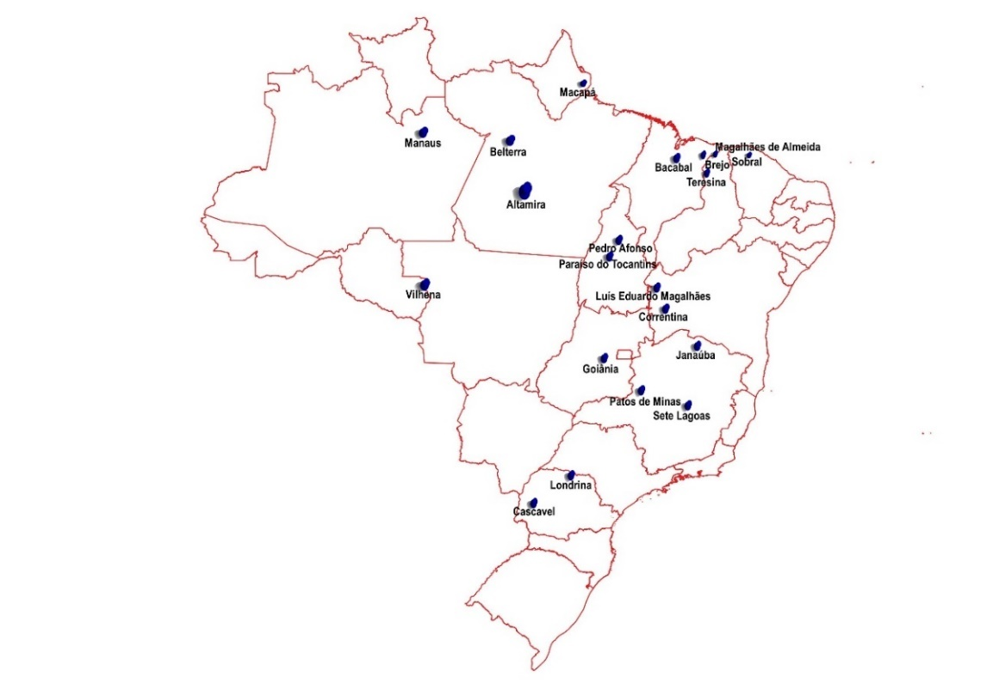
¹ Brazilian Institute of Geography and Statistics (IBGE) code for counties.
Figure 1. Location of the VCU trials, in Brazil, from where the data used in the model parameterization were obtained.

Parameterization of the model
Once we had data on the number of days for flowering (silking) and physiological maturity, for each genotype, in each year and location, it was possible to adjust the P1 parameters (period from emergence to floral initiation, expressed in degree-days above the base temperature of 8 °C, during which the plant does not respond to changes in photoperiod) and P5 (period from silking to physiological maturity, expressed in degree-days above the base temperature of 8 °C) of the model. The approach used to obtain the values of these two coefficients was trial and error, but using statistics, the agreement index (d-stat) (Willmott et al., 1985) and the mean square error – RMSE (Loague & Green, 1991), to evaluate the quality of the fit. The P1 parameter was adjusted first, changing, up or down its initial value, obtained from a preliminary parameterization (Andrade et al., 2016), and observing how close the number of days from sowing to silking was of the value observed in the VCU test. At each attempt, the d-stat and RMSE statistics were evaluated, seeking to obtain the highest d-stat value and the lowest RMSE. The same procedure was used to adjust P5, comparing the number of days, simulated and observed, from sowing to physiological maturity and also evaluating the d-stat and RMSE statistics.
Observed yield data, from the VCU tests, corrected for 0% moisture (dry matter), were used to adjust the parameters G2 (maximum possible number of grains per plant) and G3 (grain filling rate during the phase of linear grain filling rate, under optimal conditions, in mg day⁻¹). As there were no observed data on the number of grains per m² and unit weight of grains, which are used to adjust G2 and G3, the same trial and error procedure was used to adjust these two parameters, simultaneously. We started with G2 and G3 values, obtained in the preliminary calibration (Andrade et al., 2016), which were increased or reduced, until the simulated yield approached the observed productivity. Likewise, d-stat and RMSE statistics were used to evaluate the goodness of fit. The procedure was repeated, generating the values of the coefficients P1, P5, G2 and G3, for each genotype.
After this first parameterization of the model, for each of the maize genotypes, a second stage was carried out, in which the yields of the 80 genotypes were simulated, for the three years of trials and in the 20 locations, considering a condition without water stress, that is, with full irrigation. To assess whether or not there was water stress during the VCU trials, the simulated yields, under conditions without water stress, were subtracted from the respective yields of each genotype, observed in the field, in each year and location. It was assumed that, where the difference between these two yields was greater than 500 kg ha⁻¹, water stress occurred in some of the growth and development phases of the crop.
Subsequently, the data observed in the VCU trials, for genotype, year and location, were divided into two groups: 1) data from trials conducted without water stress, used to improve the parameterization; and 2) data from trials conducted with some water stress, used to validate the predictive capacity of the model. It is possible that data from the same genotype, in different locations and years, were used, both in the parameterization and in the validation of the model, depending on whether or not water stress occurred in some location and/or year.
In a third step, the genotypes, which were previously separated into two groups - without water stress and with water stress - were again divided into three other subgroups C1, C2 and C3, according to the thermal sum (degree-days) from emergence to beginning of the juvenile phase (floral initiation), corresponding to the P1 coefficient, and from silking to physiological maturity, corresponding to the P5 coefficient. The values of the P1 and P5 coefficients of each genotype in the group without water stress were added and classified into C1, C2 and C3. Each subgroup C1, C2 and C3, from each group with and without water stress, represented cultivars with different thermal sums or cycle durations, since the model coefficients, P1 and P5, control the duration of the phenological phases of the maize crop.
In a fourth step, the model parameters were recalibrated for each of the subgroups C1, C2 and C3, using observed data on cultivar, year and location, from trials conducted without water stress. Note that, this time, the parameterization was carried out for a group of cultivars and no longer individually, for each genotype, as previously. In this way, three sets of values for the coefficients P1, P5, G2 and G3 were obtained, one for each data subgroup, corresponding to three cultivars, with three different thermal sums (degree-days), equivalent to three cycle durations. To perform the recalibration, we started with the average values of P1, P5, G2 and G3, obtained for each genotype, from each subgroup. The procedure used, of trial and error and evaluation of d-stat and RMSE statistics, was the same as that used in previous parameterizations.

Assessment of the model’s predictive capacity
The fifth stage of the model adjustment process, before its application in ZarcPro-Milho, consisted of evaluating its predictive capacity, after reparameterization and generation of coefficients for the three cultivar groups, C1, C2 and C3. The three groups of observed data, whose VCU trials were subjected to some water stress, classified according to the simulated thermal sum of some phases of the crop, were used in this stage of the procedure.

Application of the model in ZarcPro-Milho
ZarcPro establishes the sowing period for cultivars with different cycle lengths, risk levels, available soil water classes and expected (simulated) yield levels. The simulated maize yield, for each grid point, was obtained with CSM-CERES-Maize, previously parameterized and evaluated, using the base containing 34 years of daily weather data, six modal soil profiles and coefficients (parameters) for three maize cultivar groups, obtained during the model parameterization process. Additionally, the model was fed with management details of a maize crop that did not suffer other stresses, except water and thermal, and with decision criteria on soil moisture conditions at the beginning of the simulations and at the time of sowing. The model was run for different scenarios of sowing dates, classes of water available in the soil and cultivars with different cycles. The simulated yield data were then used to establish risk levels for different values of expected productivity, cultivar, class of water available in the soil and sowing time. Details of the procedures are described below.

Management of maize crop
Zarc assumes that the only stresses to which the crop is subjected are water and thermal stress, the latter represented by frost and temperature above the limit tolerable by the crop. It was assumed in ZarcPro-Milho, that the crop should not be subjected to biotic or abiotic stresses, in addition to the two already considered. Therefore, the CSM-CERES-Maize model was fed with management data capable of preventing maize from suffering any nutritional stress or being subjected to another type of limitation that could reduce its yield, such as low stand or insufficient fertilization. The effect of pests, diseases and weeds was also not considered.
In the model parameterization and evaluation process, it was assumed that in the trials the maize crop had a row spacing of 0.70 m, a planting depth of 0.05 m and a plant population in accordance with the note in the spreadsheet for each VCU trial. Planting fertilizer consisted of 60 kg ha⁻¹ of N and 140 kg ha⁻¹ of P₂O₅, as monoammonium phosphate, MAP (NH₄H₂PO₄), plus 80 kg ha⁻¹ of K₂O, as potassium chloride, all released at 0.08 m depth, next to the maize row. Top dressing was split at 25 days after sowing and 40 days after sowing (DAS), each with 150 kg ha⁻¹ of N, as urea (CH₄N₂O).
In the phase of applying the model in ZarcPro, it was considered a population of 68 thousand plants per hectare, with row spacing of 0.50 m. The other management strategies were the same as those used in the model parameterization and evaluation process.
All this information was properly incorporated into the MZX-type of files, for crop management in the model.

Initial conditions required by the model
Every crop growth simulation model, based on biophysical processes, requires information about initial conditions, such as simulation start date, moisture in the soil profile and details of crop management, including cultivar data, fertilization, plant population, spacing between rows, among others.
The simulations were programmed to start three months before the maize crop sowing date, assuming that the soil profile of each of the six AW classes contained 50% of its available water (Table 3). Through the water balance, which the model performs daily, the initial soil moisture conditions tend to get closer to the real situation at the time of sowing, making the simulations more consistent.

Table 3. Water content at the lower limit of available water (PWP), at the upper limit of available water (FC) and at the limit of 50% of available water, for six classes of soil profiles in Brazil.
Depth | AW1 Class |  |  | AW2 Class
Depth | Permanent wilting point | 50% of AW1 | Field capacity | Permanent wilting point | 50% of AW2 | Field capacity
(m) | (m³ m⁻³) | (m³ m⁻³) | (m³ m⁻³) | (m³ m⁻³) | (m³ m⁻³) | (m³ m⁻³)
0.05 | 0.067 | 0.087 | 0.107 | 0.137 | 0.163 | 0.190
0.10 | 0.067 | 0.087 | 0.107 | 0.141 | 0.168 | 0.194
0.30 | 0.075 | 0.095 | 0.115 | 0.170 | 0.197 | 0.223
0.50 | 0.078 | 0.098 | 0.117 | 0.185 | 0.212 | 0.238
0.70 | 0.079 | 0.100 | 0.120 | 0.183 | 0.209 | 0.235
0.90 | 0.078 | 0.097 | 0.116 | 0.168 | 0.196 | 0.223
1.10 | 0.074 | 0.094 | 0.114 | 0.166 | 0.193 | 0.220
1.50 | 0.075 | 0.095 | 0.115 | 0.168 | 0.194 | 0.221
2.00 | 0.075 | 0.095 | 0.114 | 0.168 | 0.194 | 0.221
Depth | AW3 Class |  |  | AW4 Class
Depth | Permanent wilting point | 50% of AW3 | Field capacity | Permanent wilting point | 50% of AW4 | Field capacity
(m) | (m³ m⁻³) | (m³ m⁻³) | (m³ m⁻³) | (m³ m⁻³) | (m³ m⁻³) | (m³ m⁻³)
0.05 | 0.154 | 0.189 | 0.223 | 0.190 | 0.235 | 0.281
0.10 | 0.152 | 0.186 | 0.221 | 0.189 | 0.234 | 0.280
0.30 | 0.150 | 0.185 | 0.219 | 0.197 | 0.242 | 0.288
0.50 | 0.165 | 0.200 | 0.235 | 0.176 | 0.221 | 0.267
0.70 | 0.154 | 0.188 | 0.222 | 0.163 | 0.208 | 0.252
0.90 | 0.148 | 0.183 | 0.219 | 0.147 | 0.193 | 0.238
1.10 | 0.147 | 0.181 | 0.215 | 0.126 | 0.172 | 0.218
1.50 | 0.154 | 0.189 | 0.223 | 0.118 | 0.164 | 0.210
2.00 | 0.153 | 0.188 | 0.223 | 0.105 | 0.150 | 0.196
Depth | AW5 Class |  |  | AW6 Class
 | Permanent wilting point | 50% of AW5 | Field capacity | Permanent wilting point | 50% of AW6 | Field capacity
(m) | (m³ m⁻³) | (m³ m⁻³) | (m³ m⁻³) | (m³ m⁻³) | (m³ m⁻³) | (m³ m⁻³)
0.05 | 0.187 | 0.248 | 0.308 | 0.228 | 0.307 | 0.387
0.10 | 0.183 | 0.243 | 0.304 | 0.226 | 0.305 | 0.385
0.30 | 0.177 | 0.237 | 0.297 | 0.229 | 0.309 | 0.388
0.50 | 0.191 | 0.252 | 0.312 | 0.238 | 0.317 | 0.396
0.70 | 0.183 | 0.242 | 0.302 | 0.218 | 0.299 | 0.379
0.90 | 0.178 | 0.237 | 0.297 | 0.216 | 0.296 | 0.375
1.10 | 0.170 | 0.230 | 0.289 | 0.227 | 0.307 | 0.386
1.50 | 0.162 | 0.223 | 0.284 | 0.230 | 0.310 | 0.389
2.00 | 0.158 | 0.218 | 0.277 | 0.223 | 0.303 | 0.382

Decision criteria implemented directly in the model
As a criterion for whether or not to carry out sowing, the model evaluates whether the water depth stored in the profile, up to a depth of 0.30 m, expressed as a percentage of the available water capacity, AWC, is between a lower limit, defined for each of the six classes of soil, and the upper limit that is fixed at 100%. The lower limits, established for classes of available soil water from one to six, were 80%, 75%, 70%, 65%, 55% and 50%, respectively. It is worth mentioning that the available water class “1” has the lowest water content, corresponding to a soil with a sandy texture, while the available water class “6” has the highest moisture content. When applying these decreasing percentages to soils with increasing AW classes, the values of the water depth stored in the profile necessary to carry out sowing are 9.6 mm, 11.9 mm, 14.5 mm, 17.7 mm, 19.8 mm and 23.8 mm, respectively.
Another criterion defined in the model for successful crop establishment was in relation to air temperature, taken as a proxy for soil temperature. It was assumed that, if the minimum air temperature, measured in the meteorological shelter, is equal to or lower than 3 °C, for one day (adapted from Miedema, 1982), including during sowing, the model definitively stops the growth of the maize plant. Additionally, for days with the air temperature in the shelter below 8 °C, which is considered the base temperature for maize, the model stops the growth and development of the plant, resuming them when the temperature exceeds this baseline value again.

Simulated scenarios
To obtain simulated grain yields, to be used in the implementation of ZarcPro-Milho, several management files were created, which indicated when and how the crop was sown and cultivated. As there are three groups of cultivars, C1, C2 and C3, with different cycles, and six soil classes, with different levels of available water, there are 18 scenarios, which gave rise to 18 management files in the model format (MZX).
To allow the establishment of sowing windows, the model was programmed to sow maize every 10 days throughout the year, starting on January 3rd and extending until December 27th, totaling 36 sowing periods (Table 4). The combination of three cultivars, six soil classes and 36 sowing dates generated 648 scenarios. These scenarios were simulated for each of the 34 years of the historical series of daily weather data, which corresponds to 22,032 simulated yield values, which were used to determine the risk levels for each scenario.

Table 4. Planned sowing dates throughout the year.
Number ten-day period | Sowing date | Number ten-day period | Sowing date | Number ten-day period | Sowing date
1 | 5/jan. | 13 | 5/may | 25 | 5/sep.
2 | 15/jan. | 14 | 15/may | 26 | 15/sep.
3 | 25/jan. | 15 | 25/may | 27 | 25/sep.
4 | 5/feb. | 16 | 5/jun. | 28 | 5/oct.
5 | 15/feb. | 17 | 15/jun. | 29 | 15/oct.
6 | 25/feb. | 18 | 25/jun. | 30 | 25/oct.
7 | 5/mar. | 19 | 5/jul. | 31 | 5/nov.
8 | 15/mar. | 20 | 15/jul. | 32 | 15/nov.
9 | 25/mar. | 21 | 25/jul. | 33 | 25/nov.
10 | 5/apr. | 22 | 5/aug. | 34 | 5/dec.
11 | 15/apr. | 23 | 15/aug. | 35 | 15/dec.
12 | 25/apr. | 24 | 25/aug. | 36 | 25/dec.

Verification of the environmental conditions necessary to carry out sowing, as described in the previous section, begins on the third day of a ten-day period. If the criterion is met, planting is carried out, otherwise, the model evaluates the subsequent day and so on until the seventh day of the ten-day period. If the criterion is not met on any of the five central days of the ten-day period, planting is not carried out, yield is assumed to be zero and it is passed on to the next ten-day period. This criterion ensures that sowing is only carried out if soil moisture is within the limits established for each class of available soil water.

Levels of expected yield (EY) and of climate risk
ZarcPro-Milho considers ten levels of simulated EY, which vary from one to ten tons of maize per hectare, in order to range from more restrictive soil and climate conditions and a low level of cultivation technology to more favorable soil and climate conditions and medium to high level of cultivation technology. Furthermore, three levels of climate risk were assumed, 20%; 30% and 40%, in addition to being unsuitable or outside the sowing window, with a risk greater than 40%.
The evaluation of this methodology was implemented in an electronic spreadsheet (Figure 2), wherein, for each location, 34 simulated yield values were inserted (one for each year of weather data), for each of the 648 established scenarios (three groups of cultivars, six classes of water available in the soil and 36 ten-day periods). For each of these 648 scenarios, it was determined the empirical probability of simulated yields lower than each one of the ten EY levels. These probability values correspond to the risk levels for obtaining simulated yields lower than the EY levels. Sowing windows were established, considering each risk level (20%, 30% and 40%), each EY level, each reference cultivar and each class of water available in the soil.
The simulations were processed for each location of a meteorological station. Subsequently, the results were interpolated and, finally, the risks were assessed for each municipality in the country. In this last stage, if at least 20% of the county's area presents a lower risk than those considered (from 20% to 40%), the county is classified with that risk, that is, the county is considered suitable for growing maize. Otherwise, the county is considered unfit. The risk values for each ten-day period, EY level, soil AW class and cultivar were spatialized to generate ZarcPro-Milho maps for all over Brazil.
The spreadsheet cells content will be described ahead, taking Figure 2 as an example.
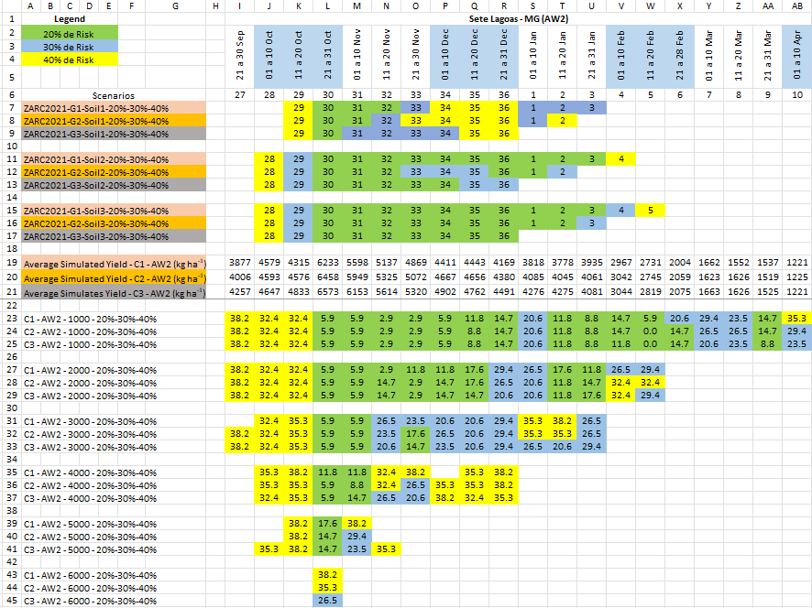
Figure 2. Maize sowing periods, estimated by ZarcPro-Milho, for the soil class with available water AW2 (0.53 mm cm⁻¹), three groups of cultivars, different levels of expected productivity and three levels of risk, compared to the traditional Zarc, for the county of Sete Lagoas – MG, Brazil.

In cells 1A to 4E, is shown the legend of the risk levels, with the respective colors that will appear in the cells of the sowing periods depicted in the same figure. In cells 2I to 6AB, the dates and ten-day periods of the sowing period are identified, which may be different for each class of available soil water and each county. The ten-day period 1 (cell 6S in Figure 2) corresponds to the sowing period from January 1st to 10th. In cells 7A to 17G, there are the legends of the scenarios considered in the traditional Zarc: three groups of cultivars (G1, G2 e G3), three classes of soil AW (Soil 1, Soil 2 e Soil 3) and three levels of risk, green (up to 20%), blue (21 to 30%) and yellow (31 to 40%), for Sete Lagoas - MG.
In cells 7I to 17AB, the sowing windows are shown. The numbers inside the cells correspond to the ten-day periods. Note that, in Soil 2 and cultivar from group C1, the sowing window goes from the ten-day period number 28 (11J) to ten-day period number 4 (11V). Planting in ten-day period 28 and 4 presents a risk of 31% to 40% (yellow); in ten-day period 29 the risk is 21% to 30% (blue) and in ten-day period 30 to 36 and 1 to 3, the risk is equal to or less than 20% (green). White cells present a risk greater than 40%, considered very high and therefore would be a planting periods not accepted in the Agricultural Activity Guarantee Program - Proagro and in the Rural Insurance Premium Subsidy Program - PSR. From line 19 downwards, the data presented refers to the results of ZarcPro-Milho. In cells 19A to 21G, there are the legends for the average simulated yield, which in the case of figure 2, are for Soil 2 and cultivars from groups C1, C2 and C3.
The average simulated yield in ZarcPro-Milho, for 34 years, without association with risk levels, are presented in cells 19I to 21AB, for each cultivar and ten-day period, for soil with AW2. Cells 23A to 25G contain cultivar identifications (C1, C2 and C3), water available in the soil (AW2), risk level (20%, 30% and 40%) and expected maize yield level which, in this case, it is 1,000 kg ha⁻¹. In cells 23I to 25AB, the sowing periods are marked in colors for the scenarios identified in cells 23A to 25G. The numbers inside the cells are the percent probability of the simulated yield being equal to or lower than the expected yield (EY), indicated in the legend which, in this case, is 1,000 kg ha⁻¹, which corresponds to the risk of simulated yield being exceeded. The colors in cells 23I to 25AB indicate the risk levels as per the legend in cells 1A to 4E. In the other lines of the spreadsheet, the sowing periods and risk levels for other EY levels are presented.

Results and discussion
Figure 3 shows the observed and simulated yields of four maize genotypes, among the 80 used in the parameterization process. It is observed that, based on the values of the statistics d-stat and RMSE, the parameterization of the model (adjustment of the coefficients P1, P5, G2 and G3), individually, for each genotype, was successful, since the values of d-stat are above 0.79 and of RMSE are below 1,825 kg ha⁻¹. The closer to 1 the d-stat and the lower are the RMSE, the closer the simulated values are of those observed. It is worth mentioning that the data were obtained from field trials, in which the control of experimental conditions is not always the most suitable for modeling purposes.

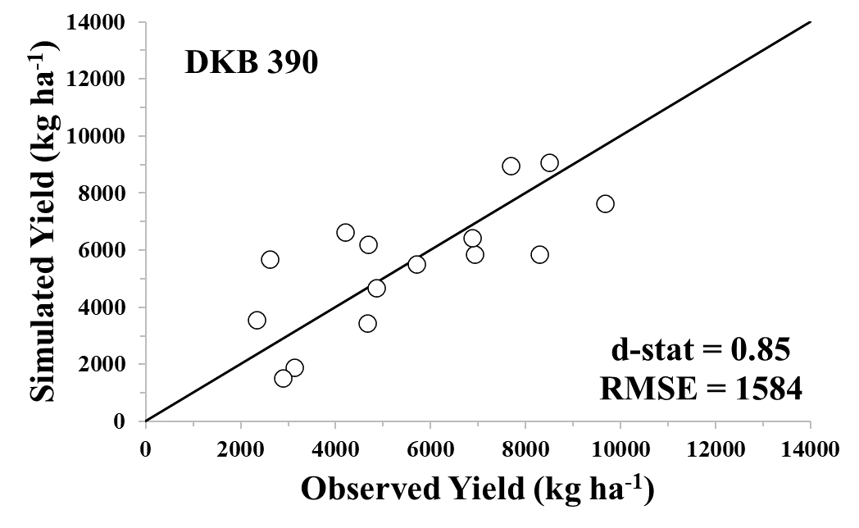 | 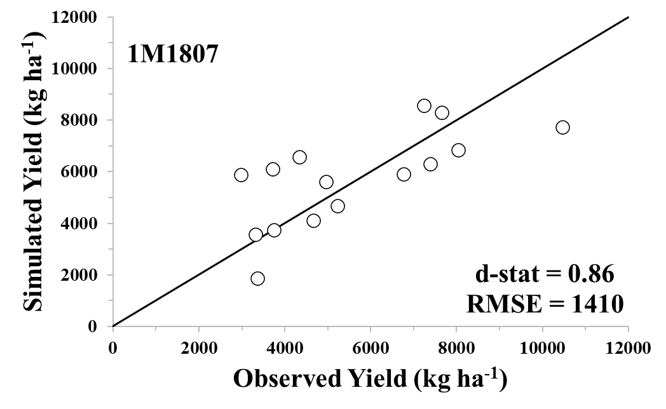
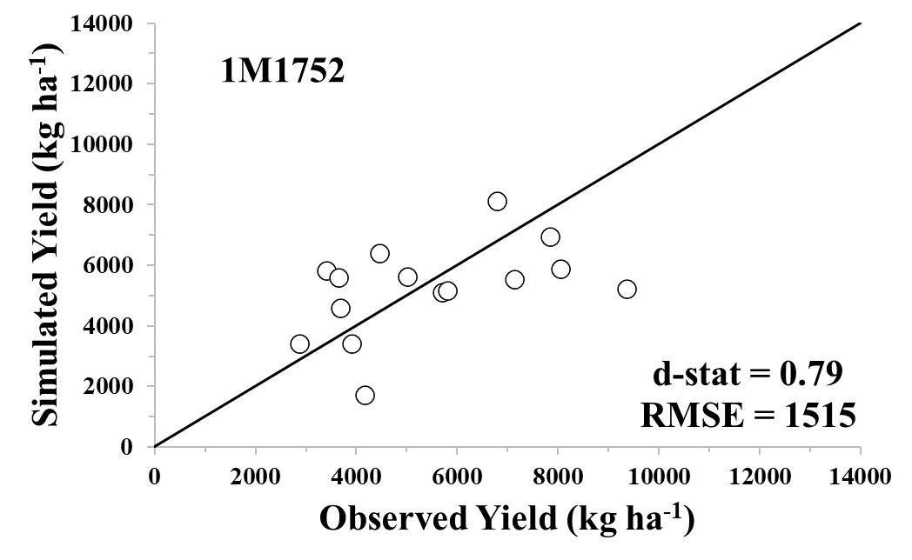 | 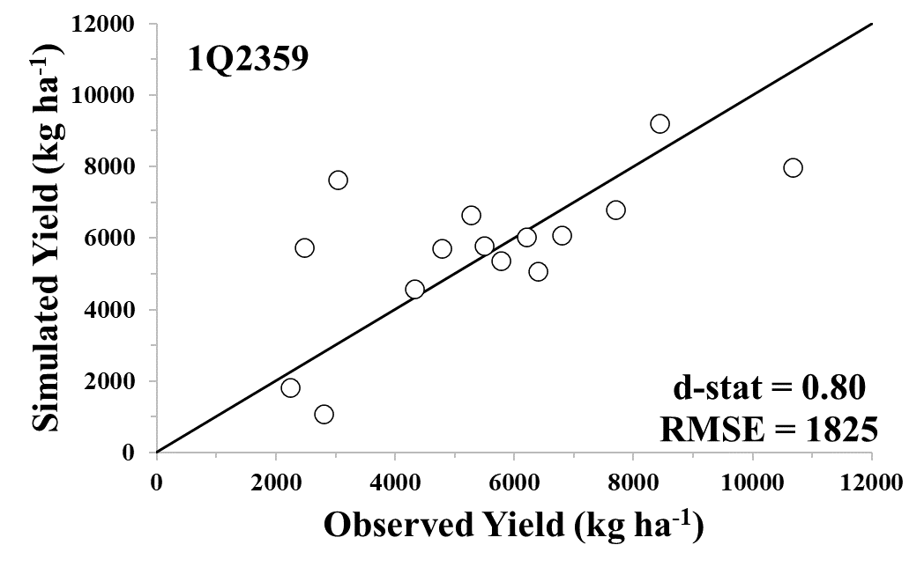
Figure 3. Observed versus simulated yield, obtained after adjusting the coefficients P1, P5, G2 and G3, individually, for the genotypes DKB 390, 1M1807, 1M1752 and 1Q2359.

The values of the coefficients, obtained after reparameterization of the model by group of cultivars, classified by the thermal sum of some phenological phases, are presented in Table 5.

Table 5. Parameters of the simulation model, adjusted for the three cultivars (C1, C2 and C3), with different days to silking and to physiological maturity (cycle).
Cultivar | Parameters of the model
Cultivar | P1 | P5 | G2 | G3 | PHINT
Cultivar | (degree-day) | (degree-day) | (grain plant⁻¹) | (mg day⁻¹) | (degree-day)
C1 | 200 (54 DAS*) | 864 (105 DAS) | 881 | 5,51 | 45,5
C2 | 230 (56 DAS) | 893 (109 DAS) | 884 | 5,52 | 45,5
C3 | 240 (58 DAS) | 910 (111 DAS) | 879 | 5,49 | 45,5
*DAS: days after sowing. Values in parentheses are the number of days to silking (column 2) and to physiological maturity (column 3).

It is noted that the differences between the cultivars (C1, C2 and C3), considering both the values of the adjusted parameters and the number of days to silking and to physiological maturity, are very small, indicating that the genotypes used in parameterization are physiologically very similar, with a tendency to have a shorter cycle. Certainly, an adjustment to the parameterization will have to be made, possibly with the inclusion of more data from the southern region of the country.
Yield data, number of days to silking and number of days to physiological maturity, simulated and observed, after a new parameterization of the model, by group of genotypes, are presented in Figure 4. This parameterization by group of genotypes considerably favored the model's ability to predict maize yield, when compared to the individual parameterization of the genotypes, as demonstrated by the d-stat and RMSE statistics (Figures 3 and 4). The mean square error (RMSE) of the estimated yield ranged from 573 kg ha⁻¹ to 711 kg ha⁻¹, while the RMSE of the number of days to silking and the number of days to physiological maturity ranged from 2.8 days after sowing (DAS) to 4.0 DAS and 6.4 DAS to 9.4 DAS, respectively.
In the process of evaluating the predictive capability of the model, the simulated data of yield, number of days to silking and number of days to physiological maturity, obtained with the reparametrized model, for the three groups of cultivars, were compared with the respective data observed in the VCU trials, in which some water stress occurred. Three groups were created, classifying the data according to the thermal sum of some phases, as was done in the parameterization process. It is observed (Figure 5) that there was a greater dispersion of yield data, days to silking and days to physiological maturity, compared to the parameterization process (Figure 4) without, however, limiting the model´s application to ZarcPro-Milho.

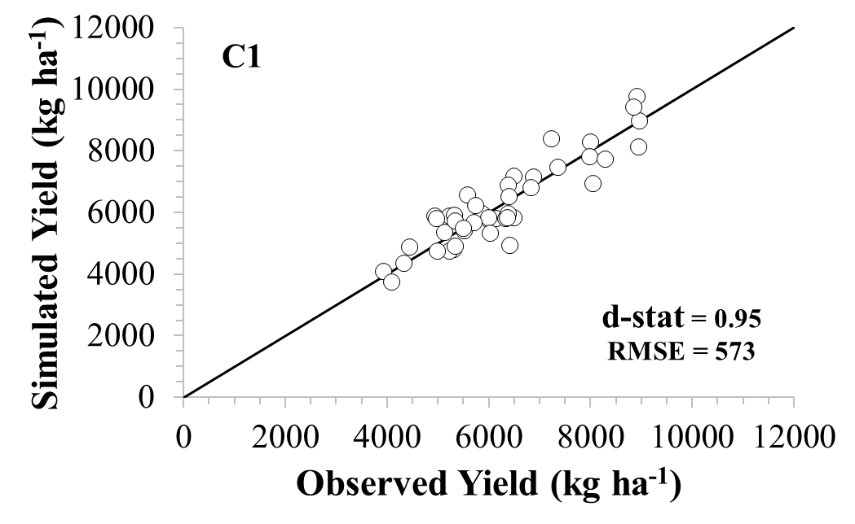 | 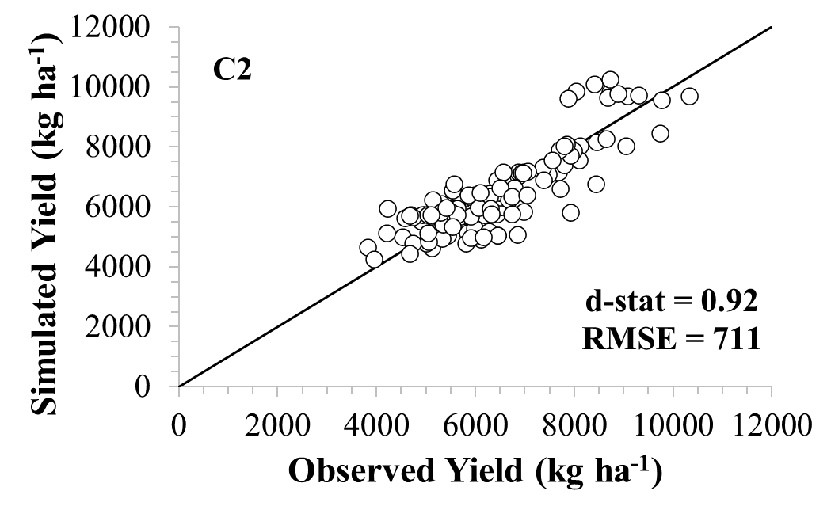
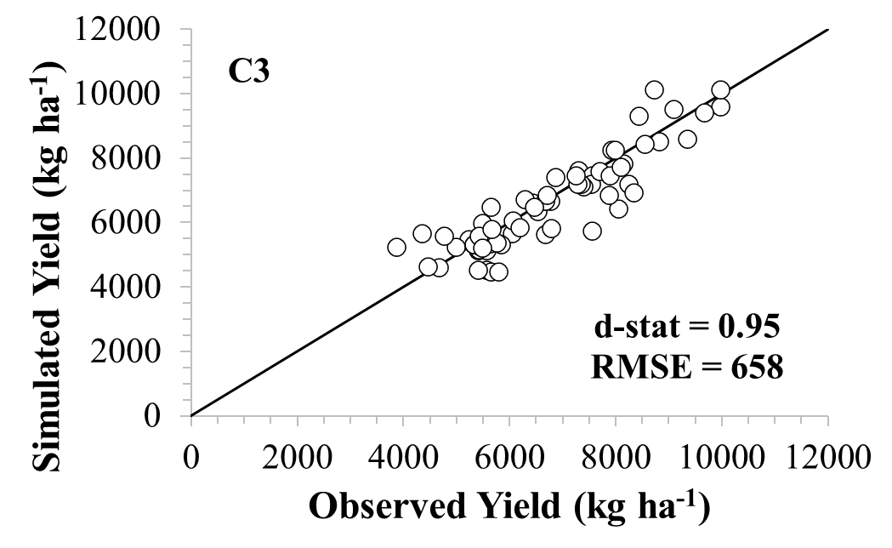 | 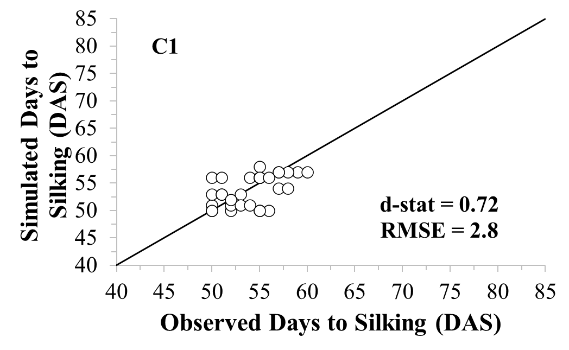
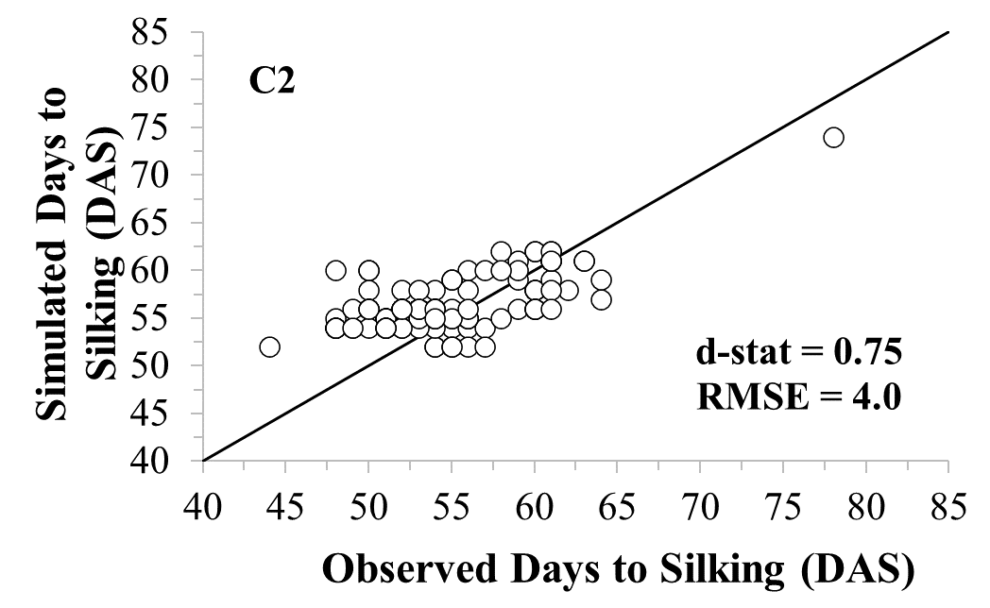 | 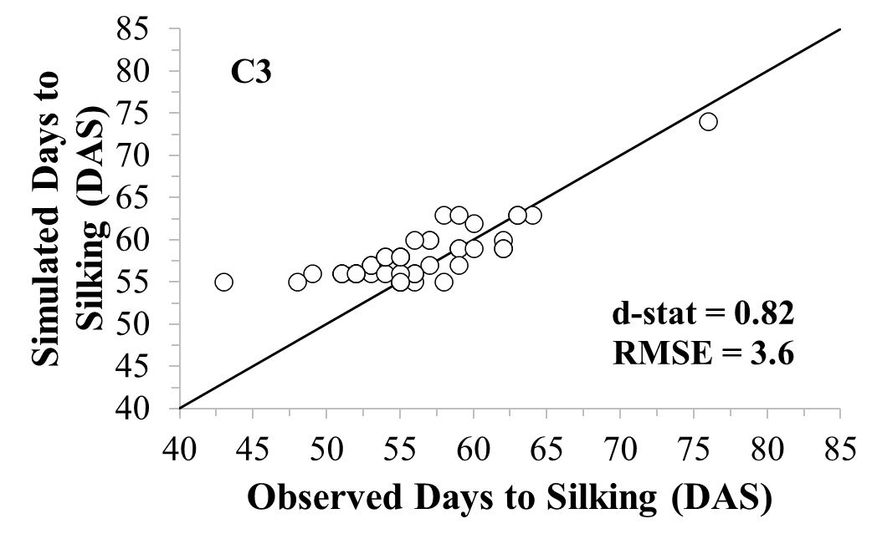
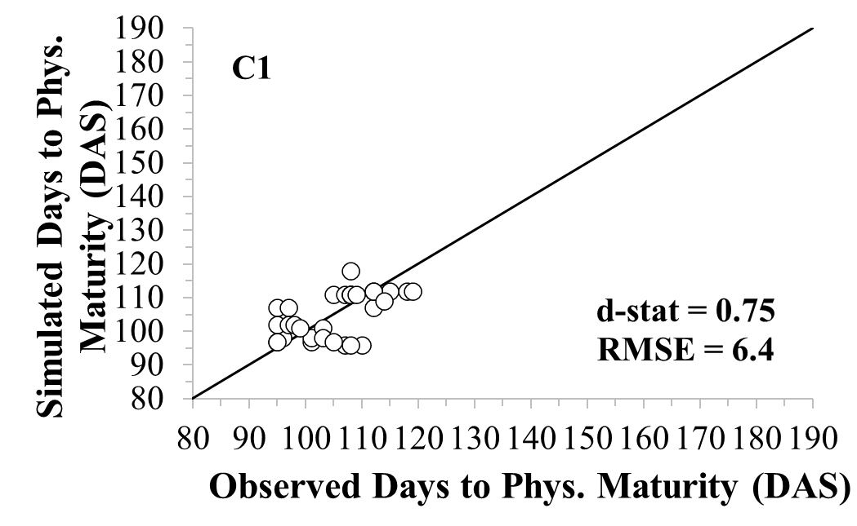 | 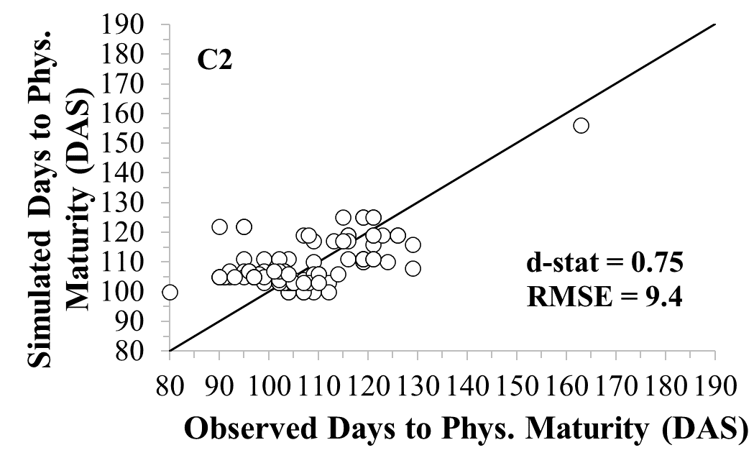
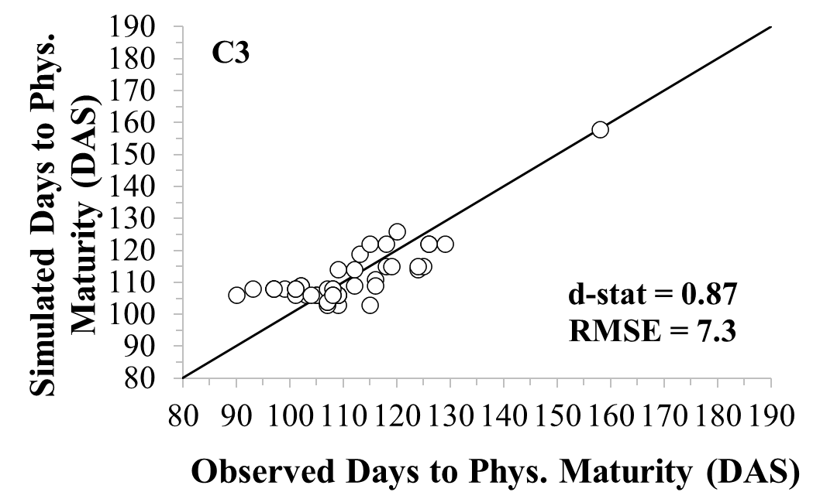
Figure 4. Yield, number of days to flowering and number of days to physiological maturity, simulated and observed, for three cultivars (C1, C2, C3), with three different thermal sums (cycles), after reparameterization of the model.

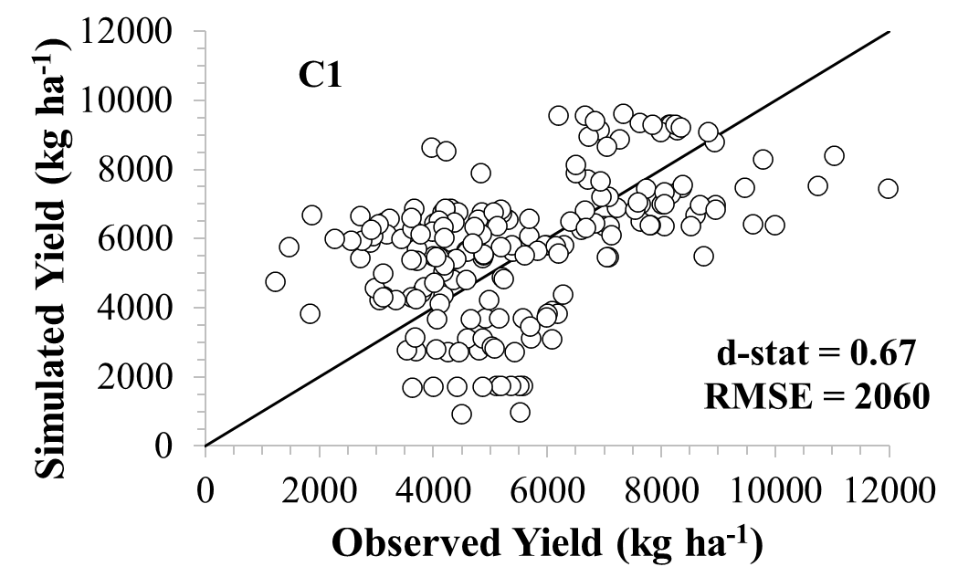 | 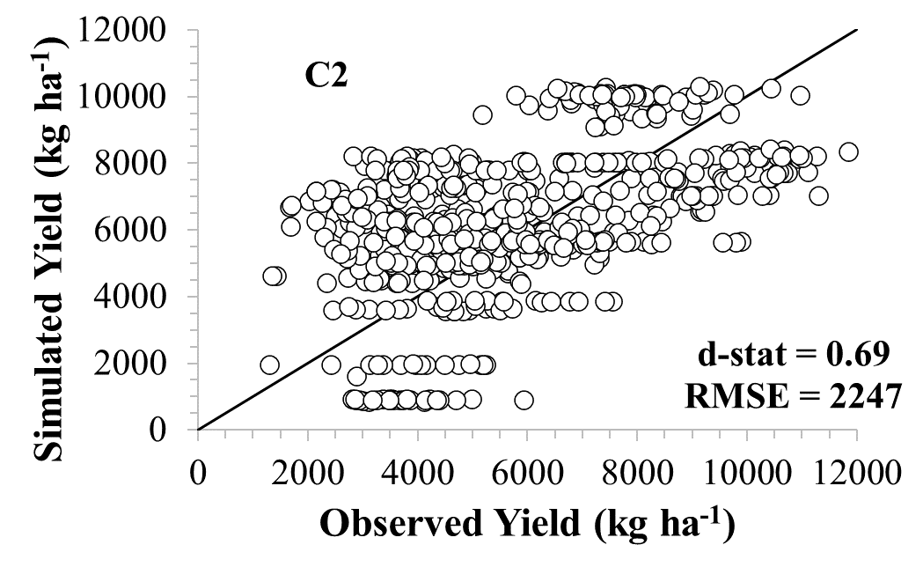
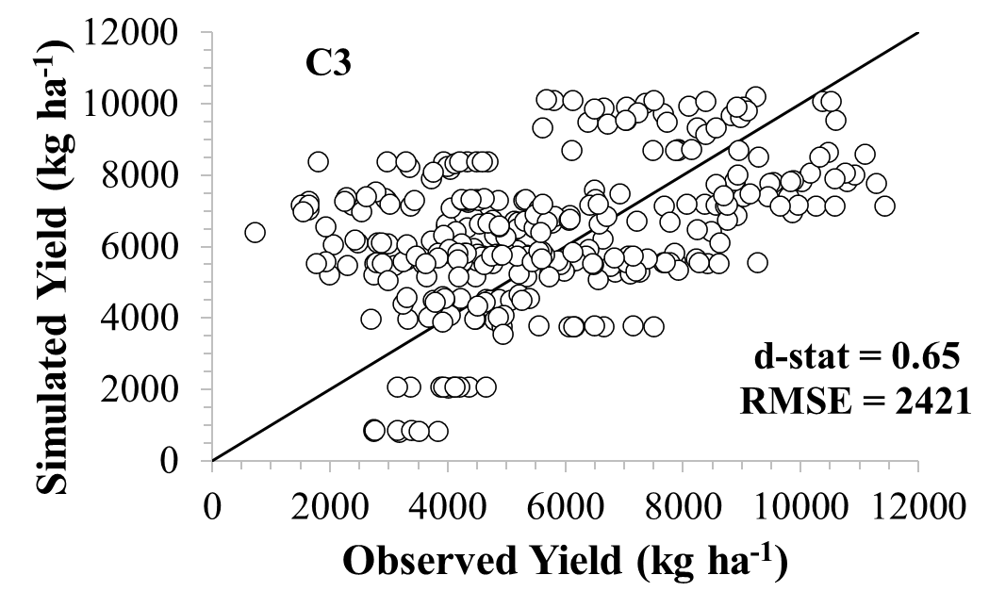 | 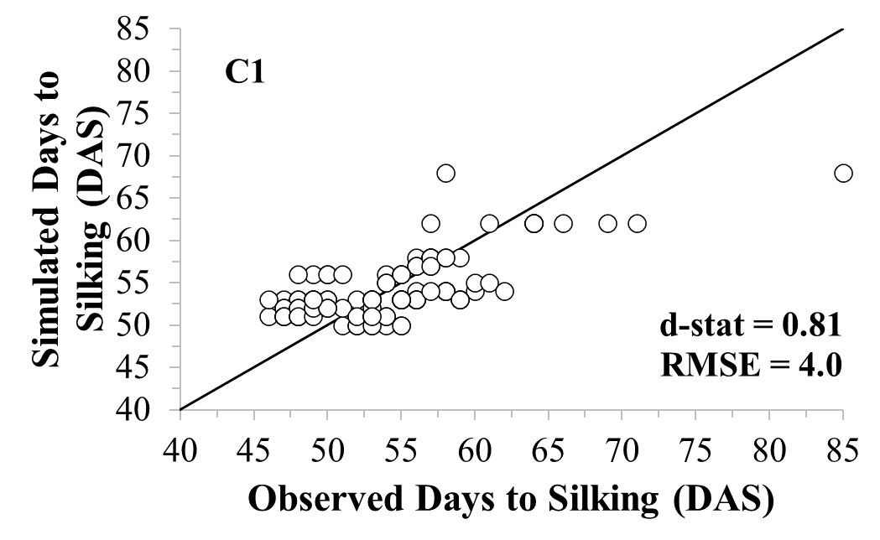
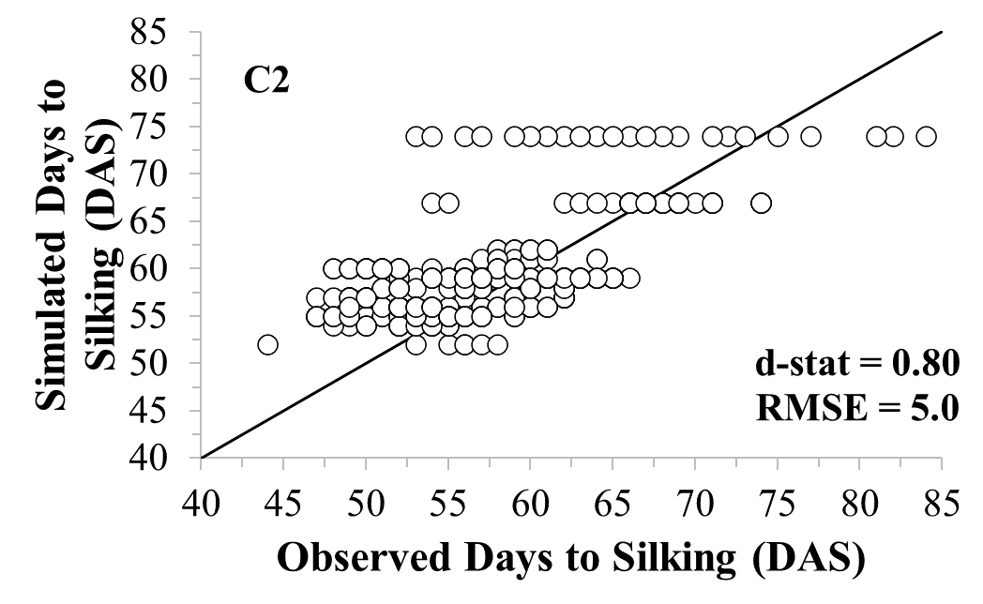 | 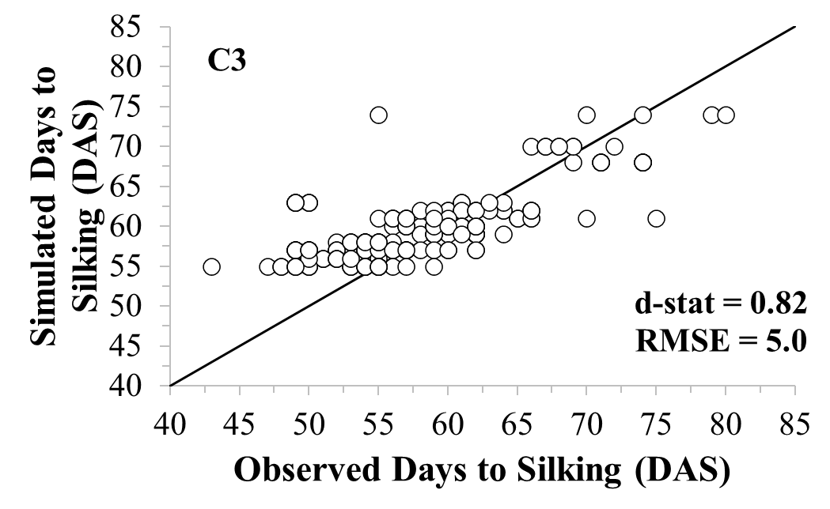
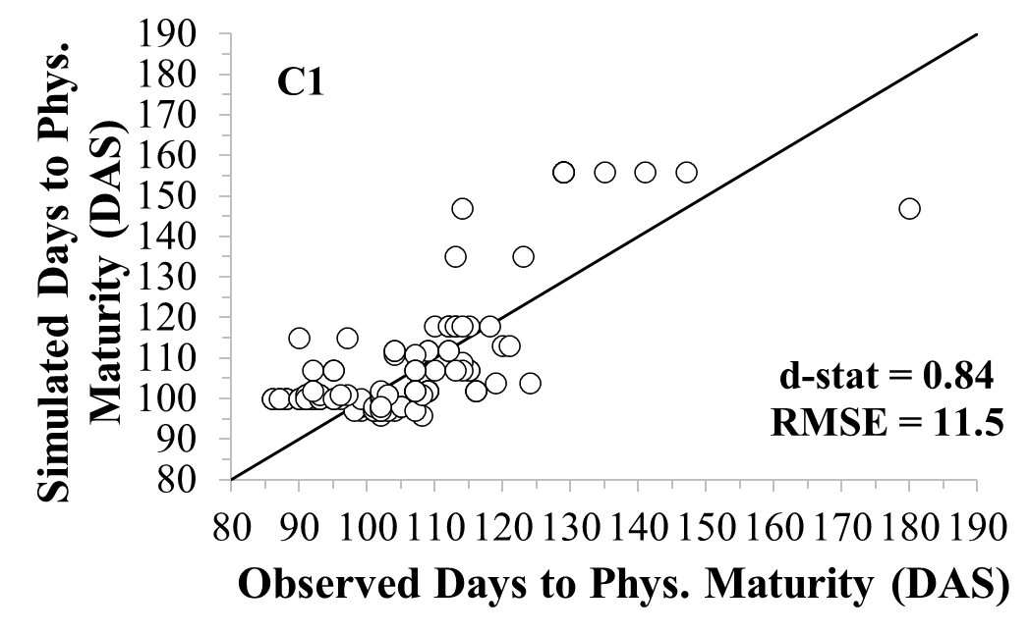 | 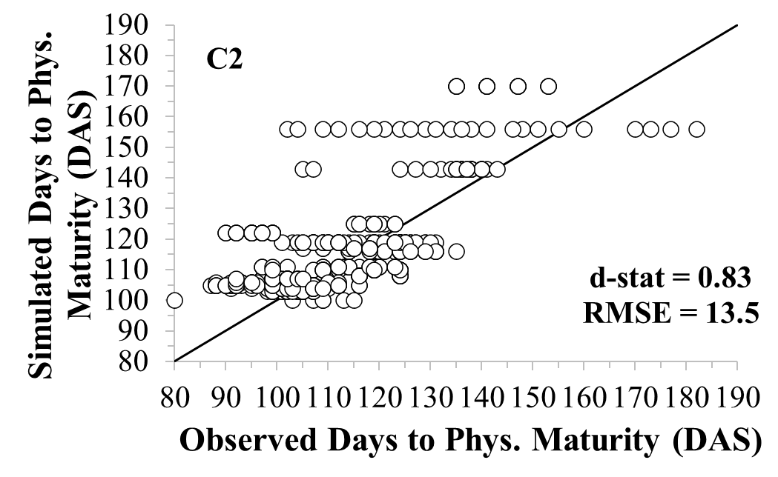
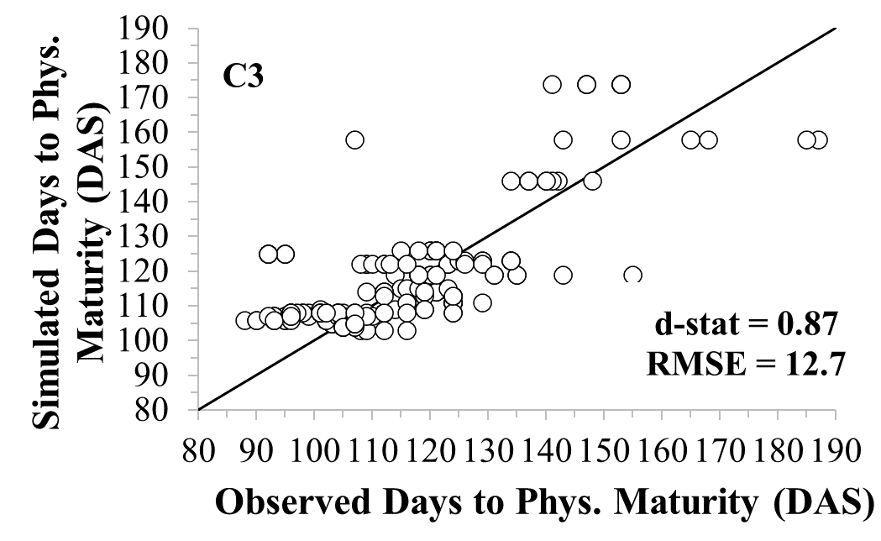
Figure 5. Assessment of the model's ability to simulate yield, number of days to silking and number of days to physiological maturity, after reparameterization, for three cultivars (C1, C2 and C3), with three different thermal sums (cycles).

It is worth emphasizing, however, that detailed information was not available on the conditions under which the VCU trials were conducted, meaning that average crop management data, interpolated soil profile and climate data and estimated physiological maturity data had to be used as input into the model.
Analyzing the data processed in the electronic spreadsheet (Figure 2), it is observed that, as expected, the average yield (34 years) simulated in ZarcPro-Milho varied considerably throughout the planting season (from September to April or from ten-day period 1 to 10 and 27 to 36), obviously, because of the climatic conditions, especially precipitation. Within the same ten-day period, the differences in simulated average yield between cultivars C1, C2 and C3 were minimal, due to the genetic similarities of the genotypes, in terms of cycle duration. The highest average yields, around 6,573 kg ha⁻¹, were simulated for the 30th ten-day period (October 21st to 31st), which coincides with the lowest risk ten-day period for EY above 3,000 kg ha⁻¹. It should be noted that simulated average yield data, not linked to risk level, were not sufficient to make a decision regarding the appropriate sowing period for maize, in Sete Lagoas - MG (Figure 2).
Analyzing data on sowing windows, linked to expected productivity (EY) and risk (Figure 2), it is observed that, as EY increases, the sowing period becomes more restrictive, for all cultivars and all risk levels. For EY equal to or less than 3,000 kg ha⁻¹, the beginning of the sowing period is brought forward by a ten-day period, while for EY of 1,000 kg ha⁻¹ or less, the sowing window extends over several ten-day periods, diverging considerably from the traditional Zarc. Although in the model, based on biophysical processes, there is a restriction for sowing in dry soil, once the crop is established, the model estimates some grain production, even if small. It is worth highlighting, however, that the interannual variability of precipitation in the region of Sete Lagoas – MG allowed, in several years, to obtain reasonable simulated yields in sowings carried out outside the traditional planting period.
On the other hand, for an EY level of 5,000 kg ha⁻¹, which is close to the current average yield of the main crop season, estimated by the Brazilian Institute of Geography and Statistics (IBGE), for Sete Lagoas - MG (IBGE, 2024), the sowing period determined using ZarcPro-Milho, considering a soil with available water AW2, was more restrictive than that established by traditional Zarc, for a soil with average water retention, regardless of the cultivar. With this new procedure, ZarcPro-Milho, there are also more ten-day periods with risk levels between 31% and 40% and, considerably fewer ten-day periods with a risk level equal to or less than 20%. The highest expected yield, for a soil with available water AW2, is 6,000 kg ha⁻¹. However, for this level of EY, the sowing window is only one ten-day period, with a risk level between 30% and 40% (Figure 2). Such restrictions are compatible with the reality of the region, which practically does not produce maize under rainfed conditions, while the production of biomass for silage is limited.
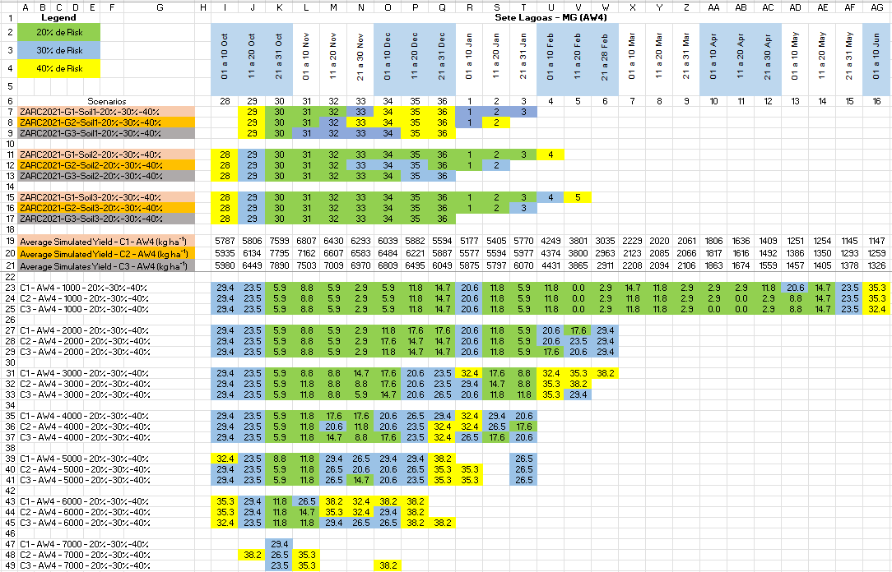
When considering a soil with greater available water, AW4, in the same municipality, the highest average simulated yield increased to 7,890 kg ha⁻¹, that is, 20% higher, compared to the AW2 soil, having occurred in the same ten-day period (Figure 6).
Figure 6. Maize sowing periods, estimated by ZarcPro-Milho, for the soil class with available water AW4 (0.91 mm cm⁻¹), three groups of cultivars, different levels of expected productivity and three levels of risk, compared to the traditional Zarc, for the county of Sete Lagoas – MG, Brazil.

Large seasonal variations in average yields and small variations between cultivars were observed, as in the scenarios with AW2. The sowing period lengthened, especially for lower EY levels, although the start of the window was delayed by a ten-day period as compared to AW2 (Figure 2). The reasons for the long maize sowing periods, in the low yielding scenarios, are the same as those described for the AW2 scenario.
With the available water level AW4, EYs reached 7,000 kg ha⁻¹, with a sowing window not as restrictive as that of soil with AW2. Furthermore, ten-day periods with a 40% risk level decreased, while those with a 30% risk level increased. For this level of available water, closer to a typical Cerrado soil (Andrade, 1987), considering expected yields between 4,000 kg ha⁻¹ and 5,000 kg ha⁻¹, the established sowing windows (October 1st to January 31st) came closer to the traditional Zarc, although with higher risks. For the EY level of 7,000 kg ha⁻¹, the sowing window is limited to a few ten-day periods, with a risk level above 30% (Figure 6).
In Cascavel - PR (spreadsheet not shown), considering a soil with available water level AW2 and all levels of expected yield (EY), the beginning of the sowing period must be in the 23rd ten-day period; in the 25th ten-day period, in Castro - PR (spreadsheet not presented); and in the 27th ten-day period, in Sete Lagoas - MG (Figure 2). For the same level of available water and EYs, the closing of the sowing periods must be in the 5th, 8th and 10th ten-day periods, respectively, for Castro, Cascavel and Sete Lagoas. It is noted that the model was able to interrupt maize sowing in the South region, due to low temperatures.
For a soil with AW4, the opening of the sowing window was delayed by a ten-day period in Sete Lagoas (Figure 6), advanced by a ten-day period in Cascavel and by two ten-day periods in Castro. The end of the sowing period was the same as in the AW2 soil in Cascavel and Castro and extended until the 16th ten-day period in Sete Lagoas. As the risk of frost in Sete Lagoas is reduced, for very low yields, the sowing period was considerably extended in this county due to the model's difficulty in penalizing yield due to water stress, as already discussed (Figure 6). In the soil with AW2, the average yield of the three cultivars, without association with risk, were, respectively, 6,421 kg ha⁻¹, 6,990 kg ha⁻¹ and 8,337 kg ha⁻¹, in Sete Lagoas, Cascavel and Castro. The ten-day periods in which such average yields occurred were 30, 1 and 35-36, in Sete Lagoas, Cascavel and Castro, respectively. When the AW4 was considered, the 34-year average yields increased to 7,761 kg ha⁻¹, 8,733 kg ha⁻¹ and 9,991 kg ha⁻¹, respectively for Sete Lagoas, Cascavel and Castro. The ten-day period with the highest average yield were the same as those simulated for the soil with AW2, since crop yield depends more on climate conditions than on soil water retention. For the same climatic conditions, the greater availability of water in the soil played a preponderant role in the expected maize yield. On the other hand, for the same level of water availability in the soil, the climatic conditions controlled the simulated average yield levels.
Regardless of cultivar and level of available soil water, as expected yields (EY) increased, sowing periods shortened and risk levels increased, as likely. For the AW2 available soil-water scenario, the largest EYs that result in recommended windows were, respectively, 5,000 kg ha⁻¹ to 6,000 kg ha⁻¹, in Sete Lagoas (Figure 5); from 6,000 kg ha⁻¹ to 7,000 kg ha⁻¹, in Cascavel; and from 7,000 kg ha⁻¹ to 8,000 kg ha⁻¹, in Castro. In the soil condition of AW4, it is estimated that it is possible to produce maize with low risk of loss, even with higher EYs, which increased from 6,000 kg ha⁻¹ to 7,000 kg ha⁻¹, from 8,000 kg ha⁻¹ to 9,000 kg ha⁻¹ and from 9,000 kg ha⁻¹ to 10,000 kg ha⁻¹, in Sete Lagoas - MG (Figure 6), Cascavel - PR and Castro - PR, respectively. It is important to note that such yield, for a soil with available water close to that of a typical Cerrado soil, is above the averages estimated by IBGE (IBGE, 2024), for the first season. Therefore, this result exemplifies that the model makes estimates of the climatic potential of crop yield, since the values obtained are consistent with the levels achieved in the VCU trials, which are small plots and which, in general, represent the yield potential of the evaluated genotypes. Additionally, the VCU data used in model adjustments are geographically limited.
The model consistently characterized the response of maize to soils with different levels of available water, sowing times and expected yields. For a medium cycle cultivar (C2), EY of 6,000 kg ha⁻¹ and sowing in the first ten-day period of November, when it went from a soil profile with available water AW4 to an AW2 profile, the regions suitable to planting became more restrictive and the distribution of risk levels also changed, reducing areas with a risk of 20% and increasing areas unsuitable to maize cultivation (risk greater than 40%) (Figure 7). Greater soil water retention favored the increase in areas suitable to maize cultivation in the states of Rio Grande do Sul, Paraná, Minas Gerais, Bahia, Piauí, Maranhão, Mato Grosso do Sul, Mato Grosso, Acre and Amazonas.
The risks and areas unsuitable to planting maize, in a soil with available water level AW4 and sowing in the first ten days of November, increased considerably as the EY increased from 5,000 kg ha⁻¹ to 7,000 kg ha⁻¹. To obtain higher productivity, the risks are higher (Figure 8). The biggest impact was in the states of Amazonas, Pará, Rondônia, Tocantins, Piauí, Bahia, Minas Gerais, Mato Grosso, Mato Grosso do Sul, São Paulo, Paraná and Rio Grande do Sul.
Comparing the distribution of risks in a soil with available water AW4, EY of 6,000 kg ha⁻¹, cultivar C2 and sowing in the first ten-day of November and the first ten-day of February, a considerable difference was noted (Figure 9). The areas suitable for planting maize in the off-season were less restrictive in the Northeast and North, but with risks predominantly in the range of 30 to 40%. On the other hand, as expected, risks and unsuitable areas increased in the West of Bahia and in the Center-South region.

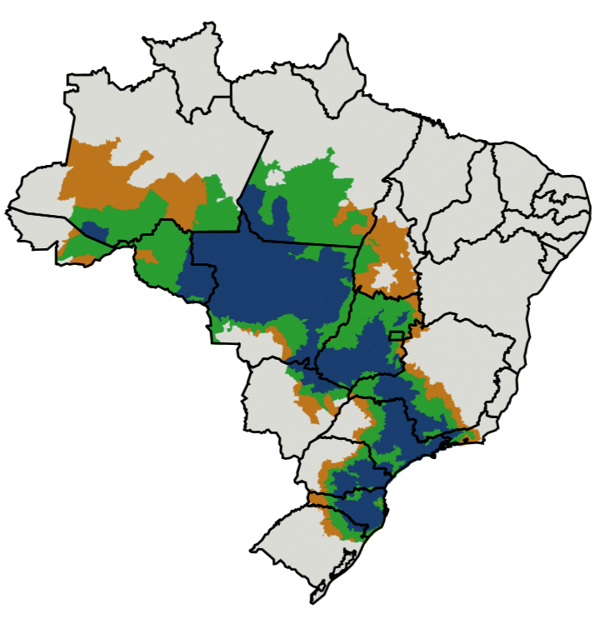 | 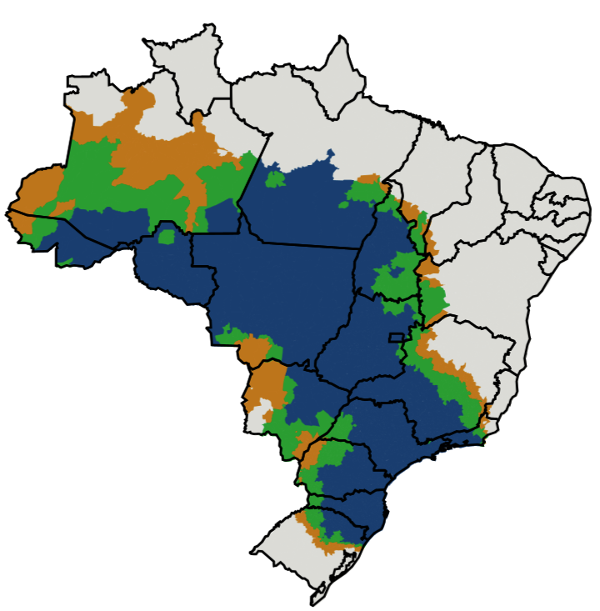
Figure 7. Spatialization of risk levels (blue=20%; green=30%; orange=40% and gray=greater than 40%), obtained by ZarcPro, for maize cultivation in Brazil, considering a medium cycle cultivar (C2), sowing in the first ten-day of November, expected productivity of 6,000 kg ha⁻¹ and available soil water level AW2 (left) and AW4 (right).

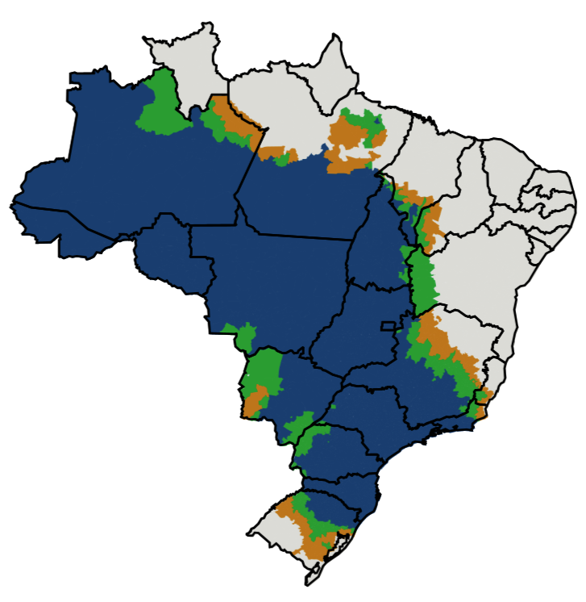 | 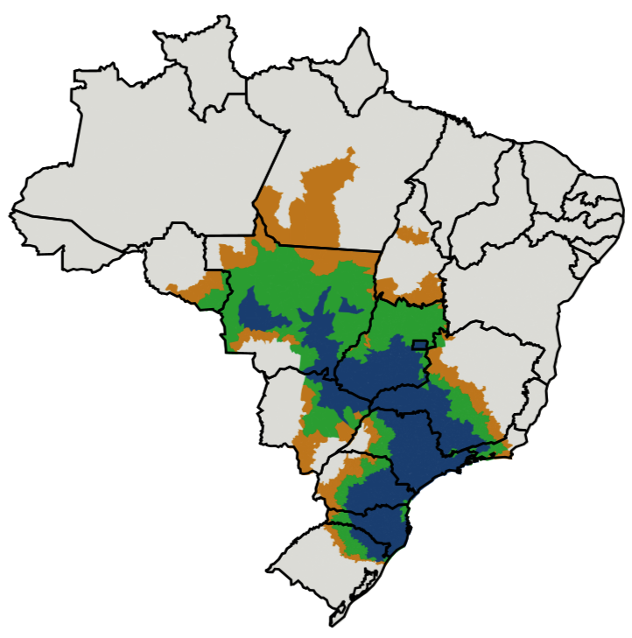
Figure 8. Spatialization of risk levels (blue=20%; green=30%; orange=40% and gray=greater than 40%), obtained by ZarcPro, for maize cultivation in Brazil, considering a medium cycle cultivar (C2), sowing in the first ten-day of November, EY of 5,000 kg ha⁻¹ (left) and 7,000 kg ha⁻¹ (right) and available water level AW4.

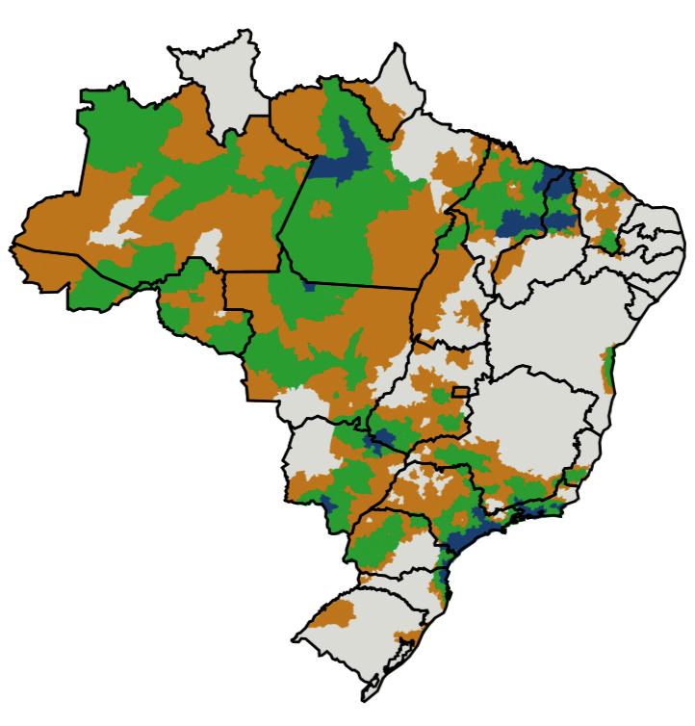
Figure 9. Spatialization of risk levels (blue=20%; green=30%; orange=40% and gray=greater than 40%), obtained by ZarcPro, for maize cultivation in Brazil, considering a medium cycle cultivar (C2), sowing in the first ten-day of November (left) and the first ten-day of February (right), expected productivity of 6,000 kg ha⁻¹ and available water level AW4.

The average maize yields, in the second harvest (off-season), from 2003 to 2015, which comprises part of the period considered in the simulations, were 4,167 kg ha⁻¹, 4,351 kg ha⁻¹, 5,257 kg ha⁻¹ and 4,796 kg ha⁻¹, respectively, for Brazil, Cascavel – PR, Castro – PR and Sete Lagoas – MG (IBGE, 2024). It is noted that the simulated expected yields are higher than the average values estimated by IBGE, since a technological increase occurred in maize cropping, with a positive impact on yields, after 2003, a period in which the VCU data, used in the parameterization of the model, were collected.
When comparing the ZarcPro-Milho methodology with that of traditional Zarc, for a yield level of 6,000 kg ha⁻¹, sown in the first ten-day of November, that is, in the first cropping season, it is observed that there is a coincidence in the distribution of risks in most regions of Brazil (Figure 10). ZarcPro, for this EY, is more restrictive than Zarc in the states of Pará, Minas Gerais, Espírito Santo, Mato Grosso do Sul and Rio Grande do Sul. In western Bahia and southern Maranhão, ZarcPro presented higher risk levels, compared to traditional Zarc. In the Southwest of Piauí, the area of low risk for maize production was reduced by the ZarcPro.

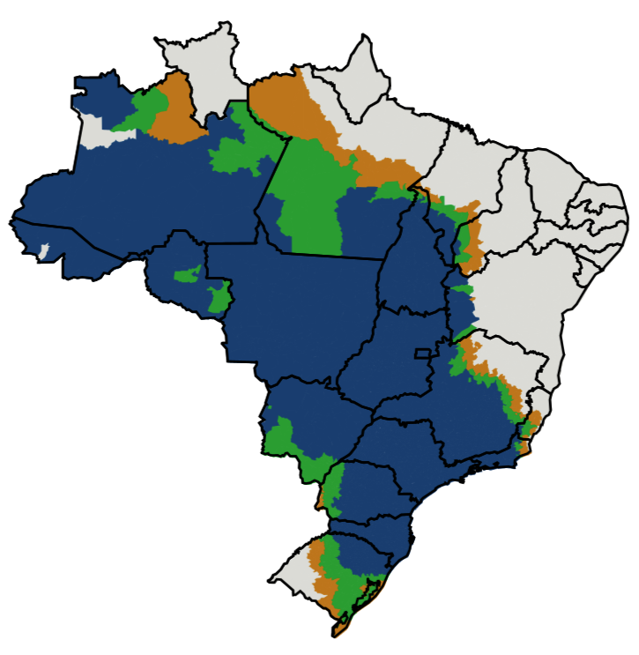
Figure 10. Spatialization of risk levels (blue=20%; green=30%; orange=40% and gray=greater than 40%) for maize crop in Brazil, considering a medium cycle cultivar for ZarcPro and a group II cultivar for traditional Zarc, sowing in the first ten-day of November, expected yield of 6,000 kg ha⁻¹ and available water level AW4 and Soil 2 of medium texture for Zarc, obtained with the ZarcPro methodology (left) and traditional Zarc (right).

In Figure 11 it can be seen that there is a reasonable agreement between the areas suitable for growing maize, sown in the first ten-day period of February (offseason), generated by ZarcPro, considering an EY of 6000 kg ha⁻¹, and by Zarc, in the largest part of the country's regions. Zarc was more restrictive in Amazonas, Ceará, Minas Gerais, São Paulo, Mato Grosso do Sul and Goiás. On the other hand, the risks were lower with Zarc, in the Central-North region, compared to ZarcPro. In Minas Gerais, ZarcPro for an EY of 6000 kg ha⁻¹ is consistent with what is currently practiced, as it is known that farmers are successfully planting maize offseason in the South, Southwest and Triângulo Mineiro regions of that state. In contrast, ZarcPro was more permissive for planting maize in the state of São Paulo (Figure 11).
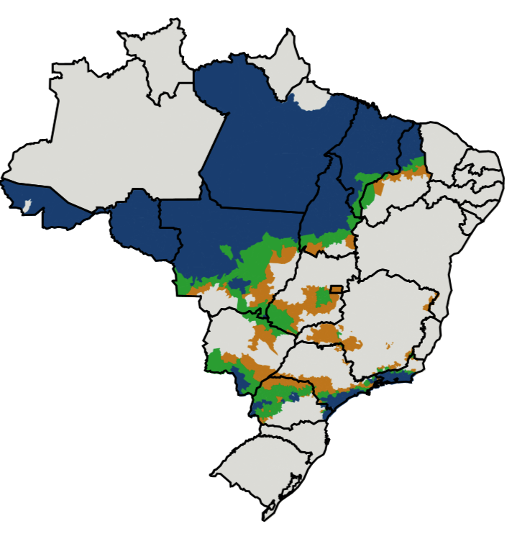
Figure 11. Spatialization of risk levels (blue=20%; green=30%; orange=40% and gray=greater than 40%) for maize in Brazil, considering a medium cycle cultivar for ZarcPro and group II cultivar for Zarc, sowing in the first ten-day period of February, EY of 6,000 kg ha⁻¹ and available water level AW4 for ZarcPro and a medium textured soil for Zarc, obtained with the ZarcPro methodology (left ) and Zarc (right).

Conclusions
Preliminary simulations, carried out with the model itself, allow separating data from trials with and without water stress and also with different cycle characteristics.
The statistical indices obtained in the parameterization and evaluation processes are suitable for applying the model in the Agricultural Zoning of Climate Risk of Maize Yield (ZarcPro-Milho).
ZarcPro-Milho establishes maize sowing periods considering cultivars with three different cycles, soils with six available water classes and three risk levels for eight yield classes.
For maize sowing in the first cropping season, it appears that the planting periods are similar between the risk map obtained with ZarcPro and that obtained with traditional Zarc. When sowing in the second cropping season, the differences may be greater, depending on the expected yield considered. At lower expected yields, such as 1000 or 2000 kg ha⁻¹, sowing periods are longer in ZarcPro than in Zarc, with the opposite situation occurring for yields of 6000 kg ha⁻¹ or greater. More similar planting periods are found for yields ranging from 3000 to 4000 kg ha⁻¹.

Author contributions

T. A. AMARAL: DSSAT´s data files preparation, performing the simulations, chart preparations, develop the maize zoning methodology, implementing the methodology in spreadsheet; C. de L. T de ANDRADE: Design the simulation scenarios, develop the maize zoning methodology, write the manuscript; S. V. CUADRA: Preparation of weather and soil database, design the simulation scenarios, review de manuscript; J. E. B. A. MONTEIRO: Design the simulation scenarios, develop the maize zoning methodology, review the manuscript; P. E de O. GUIMARÃES and R. dos S. TRINDADE: Obtaining the maize field data, review the manuscript.

Acknowledgment

Thanks to the undergraduate in Agricultural Engineering Luiz Antônio Saraiva Júnior, for preparing the map in Figure 1. To the Central Bank of Brazil and Embrapa, for the financial and physical support, respectively.

References

ANDRADE, C. de L. T. de. Balanço de água de um Latossolo Vermelho-Escuro Alico, cultivado com milho (Zea mays L.), sob irrigação por aspersão. 1987. 84 f. Dissertação (Mestrado) - Universidade Federal de Viçosa, Viçosa - MG.

ANDRADE, C. de L. T. de et al. Parametrização do modelo CSM-CERES-Maize para uma cultivar de alta produtividade. In: CONGRESSO NACIONAL DE MILHO E SORGO, 31., 2016, Bento Gonçalves. Anais... Milho e sorgo: inovações, mercados e segurança alimentar: anais. Sete Lagoas: Associação Brasileira de Milho e Sorgo, 2016.

ANUÁRIO brasileiro do milho. Santa Cruz do Sul: Gazeta, 2022. 96 p.

BERGAMASCHI, H. Desenvolvimento do déficit hídrico em culturas. In:
BERGAMASCHI, H. (coord.). Agrometeorologia aplicada à irrigação. Porto Alegre:
Universidade Federal do Rio Grande do Sul, 1992. p. 25-32.

BERGAMASCHI, H. et al. Déficit hídrico e produtividade na cultura do milho. Pesquisa Agropecuária Brasileira, v. 41, n. 2, p. 243-249, 2006. DOI: https://doi.org/10.1590/S0100-204X2006000200008.

BERGAMASCHI, H.; MATZENAUER, R. Milho. In: MONTEIRO, J. E. A. (org.).
Agrometeorologia dos cultivos: o fator meteorológico na produção agrícola. Brasília, DF: INMET, 2009. p. 239-260.

BERGAMASCHI, H. et al. Estimating maize water requirements using agrometeorological data. Revista Argentina de Agrometeorologia, v. 1, n. 1, p. 23-27, 2001.

BERLATO, M. A.; SUTILI, V. R. Determinação das temperaturas bases dos
subperíodos emergência-pendoamento e emergência-espigamento de três cultivares de
milho (Zea mays L.). In: REUNIÃO BRASILEIRA DE MILHO E SORGO, 11., 1976,
Piracicaba, SP. Anais... Piracicaba: Escola Superior de Agricultura “Luiz de Queiroz”,
1978. p. 523-527.

BIRCH, C. J.; HAMMER, G. L.; RICKERT, K. G. Temperature and photoperiod
sensitivity of development in five cultivars of maize (Zea mays L.) from emergence to
tassel initiation. Field Crops Research, v. 55, n. 1/2, p. 93-107, 1998. DOI: https://doi.org/10.1016/S0378-4290(97)00062-2.

BRASIL. Ministério da Agricultura, Pecuária e Abastecimento. Programa Nacional de Zoneamento Agrícola de Risco Climático: Portarias por Unidade Federativa. Available at: https://www.gov.br/agricultura/pt-br/assuntos/riscos-seguro/programa-nacional-de-zoneamento-agricola-de-risco-climatico/portarias. Access on: 3 nov. 2022.

BRUNINI, O.; ABRAMIDES, P. L. G.; BRUNINI, A. P. C.; CARVALHO, J. P.
Caracterizações macroclimáticas, agrometeorológicas e restrições ambientais para o
cultivo de milho em regiões tropicais baixas. InfoBibos, v. 1, n. 3, 2006.
Available at: http://www.infobibos.com.br/artigos/2006_3/ambientemilho/index.htm.
Access on: 11 dec. 2022.

DOORENBOS, J.; KASSAM, A. H. Yield response to water. Rome: FAO, 1979. 193 p. (FAO. Irrigation and Drainage Paper, 33).

DOORENBOS, J.; PRUITT, W. O. Guidelines for predicting crop water requirements. Rome: FAO, 1975. 179 p. (FAO. Irrigation and Drainage Paper, 24).

HOOGENBOOM, G. et al. Decision Support System for Agrotechnology Transfer (DSSAT): version 4.7. Gainesville: DSSAT Foundation, 2019. Available at: https://dssat.net/. Access on: 13 sep. 2023.

IBGE. Sistema IBGE de Recuperação Automática - SIDRA. Produção Agrícola Municipal: Tabela 839 – área plantada, área colhida, quantidade produzida e rendimento médio de milho, 1ª e 2ª safras. Disponível em: https://sidra.ibge.gov.br/pesquisa/censo-agropecuario/censo-agropecuario-2017. Access on: 13 mar. 2024.

JONES, J. W. et al. DSSAT cropping system model. European Journal of Agronomy, v. 18, p. 235-265, 2003. DOI: https://doi.org/10.1016/S1161-0301(02)00107-7.

KINIRY, J. R. Maize physics development. In: HANKS, J.; RITCHIE, J. T. (ed.).
Modeling plant and soil systems. Madison: American Society of Agronomy, 1991. p. 55-71. (Agronomy Monographs, 31).

LOAGUE, K.; GREEN, R. E. Statistical and graphical methods for evaluating solute transport models: overview and application. Journal of Contaminant Hydrology, v. 7, n. 1/2, p. 51-73, 1991. DOI: https://doi.org/10.1016/0169-7722(91)90038-3.

MANTOVANI, E. C. et al. Plantio. In: PEREIRA FILHO, I. A. (ed.). Cultivo do milho. 9. ed. Sete Lagoas: Embrapa Milho e Sorgo, 2015. (Embrapa Milho e Sorgo. Sistema de Produção, 1).

MIEDEMA, P. The effects of low temperature on Zea mays. Advances in Agronomy, v. 35, p. 93-128, 1982. DOI: https://doi.org/10.1016/S0065-2113(08)60322-3.

MONTEIRO, J. E. B. de A. et al. Classes de água disponível do solo para uso no Zoneamento Agrícola de Risco Climático. Campinas: Embrapa Agricultura Digital, 2022. 6 p. (Embrapa Agricultura Digital. Comunicado Técnico, 135).

NIELSEN, R. L. Kernel set scuttlebutt. West Lafayette: Purdue University, 2005. Available at:
https://www.agry.purdue.edu/ext/corn/news/timeless/kernelset.html. Access on: 11 dec.
2022.
RADIN, B.; BERGAMASCHI, H.; SANTOS, A. O.; BERGONCI, J. I.; FRANÇA, S. Evapotranspiração da cultura do milho em função da demanda evaporativa atmosférica e do crescimento de plantas. Pesquisa Agropecuária Gaúcha, v. 9, n. 1/2, p. 7-16, 2003.

REHAGRO. Produtividade do milho: como o clima atua no rendimento dos grãos?
Available at: https://rehagro.com.br/blog/clima-e-produtividade-do-milho/.
Access on: 11 dec. 2022.

RITCHIE, S. W.; HANWAY, J. J.; BENSON, G. O. How a corn plant develops. Yowa State University, 1993. (Special Report, 48). Available at: https://core.ac.uk/download/pdf/83024409.pdf. Access on: 11 dec. 2022.

SANTOS, H. G. dos et al. Sistema brasileiro de classificação de solos. 5. ed. rev. ampl. Brasília, DF: Embrapa, 2018. 356 p.

SERVIÇO GEOLÓGICO DO BRASIL. Mapa geológico do Brasil. Rio de Janeiro, 2001.

TEIXEIRA, W. G. et al. Predição da água disponível no solo em função da granulometria para uso nas análises de risco no zoneamento agrícola de risco climático. Rio de Janeiro: Embrapa Solos, 2021. (Embrapa Solos. Boletim de Pesquisa e Desenvolvimento, 272).

TOMASELLA, J.; HODNETT, M. G. Estimating soil water retention characteristics from limited data in Brazilian Amazonia. Soil Science, v. 163, p. 190-202, 1998.

TOMASELLA, J.; HODNETT, M. G.; ROSSATO, L. Pedotransfer functions for the estimation of soil water retention in Brazilian soils. Soil Science Society of America Journal, v. 64, n. 1, p. 327-338, 2000. DOI: https://doi.org/10.2136/sssaj2000.641327x.

XAVIER, A. C.; KING, C. W.; SCANLON, B. R. Daily gridded meteorological variables in Brazil (1980-2013). International Journal of Climatology, v. 36, n. 6, p. 2644-2659, 2016. DOI: https://doi.org/10.1002/joc.4518.

WILLMOTT, C. J. et al. Statistics for the evaluation and comparison of models. Journal of Geophysical Research, v. 90, n. C5, p. 8995-9005, 1985. DOI: https://doi.org/10.1029/JC090iC05p08995.

YANG, A.; DOBERMANN, K. G.; CASSMAN, D. T.; WALTERS, P. GRASSINI User manual of the hybrid-maize. Lincoln: University of Nebraska, 2016.

Comunicação pessoal de Miguel Cooper, Universidade de São Paulo, 2019.

