Supplemental Material
Table S1: Mean, variance, minimum (Min) and maximum (Max) of the response variable: number and dry weight of nodules by level of categorical (Cultivars and Inoculant) and quantitative (Dose) predictors.
Effects | Level | Nodulation (NN) |  |  |  | Dry weight of Nodules (DWN)
Effects | Level | Mean | Variance | Min | Max | Mean | Variance | Min | Max
Cultivars | LEC 01-11 | 131.52 | 17517.61 | 0 | 645 | 0.206 | 0.036 | 0 | 0.882
Cultivars | FT 0875 | 106.98 | 10764.90 | 0 | 449 | 0.166 | 0.027 | 0 | 0.673
Cultivars | LEC 01-10 | 129.03 | 13652.61 | 0 | 533 | 0.223 | 0.054 | 0.003 | 1.186
Cultivars | CNFC 10762 | 101.73 | 10553.08 | 0 | 525 | 0.151 | 0.030 | 0 | 0.988
Inoculant | CIAT 899 | 204.75 | 13895.48 | 25 | 533 | 0.285 | 0.040 | 0.012 | 0.988
Inoculant | UFLA 02-100 | 85.26 | 9739.39 | 0 | 645 | 0.153 | 0.023 | 0 | 0.754
Inoculant | AI | 61.94 | 4200.62 | 0 | 374 | 0.122 | 0.034 | 0 | 1.186
Dose de N (kg/ha) | 0 | 112.60 | 11018.84 | 0 | 448 | 0.223 | 0.035 | 0 | 0.754
Dose de N (kg/ha) | 20 | 161.85 | 14203.49 | 2 | 449 | 0.293 | 0.060 | 0.001 | 1.186
Dose de N (kg/ha) | 40 | 105.46 | 13630.59 | 2 | 525 | 0.175 | 0.045 | 0.004 | 0.988
Dose de N (kg/ha) | 60 | 101.75 | 11900.06 | 0 | 533 | 0.136 | 0.015 | 0 | 0.500
Dose de N (kg/ha) | 80 | 104.92 | 13418.84 | 0 | 645 | 0.106 | 0.012 | 0 | 0.515

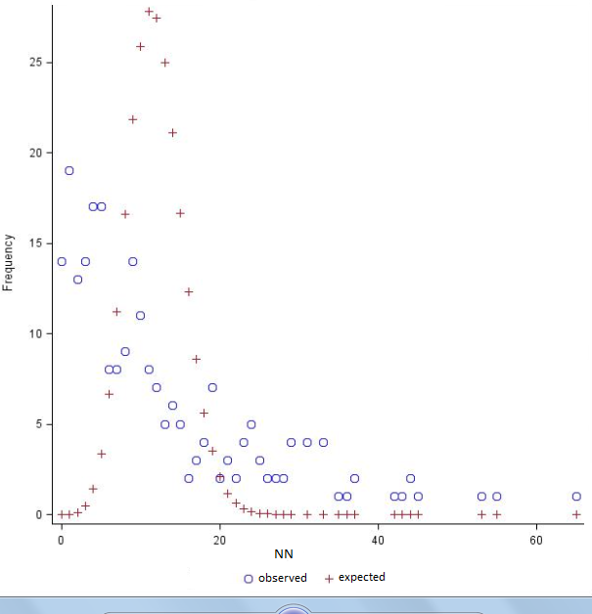

Figure S1: Observed frequency and expected Poisson distribution of number of nodules (NN) in Phaseolus vulgaris (L).

Appendices

GLMM log-likelihood functions for regression of number of nodules with inoculant CIAT-899 and doses of nitrogen.

proc nlmixed data=inum;
parms int = 212.2562, b0 = -3.95446, b1 = 27.40802, a_0 = 0, a_1 = 0;
eta_lambda = int + b0*D + b1*D**.5;
mean = exp(eta_lambda);
eta_k = a_0 + a_1*D;
k = exp (eta_k);
loglike = (lgamma(NN+(1/k))-lgamma(NN+1)-lgamma(1/k)+NN*log(k*mean) (NN+(1/k))*log(1+k*mean));
model NN ~ general(loglike);
predict mean out=p;
run;

GLMM log-likelihood function for regression of number of nodules with inoculant UFLA 02-100 and doses of nitrogen.

proc nlmixed data=indois;
parms int = 74.1189, b0 = -13.7785, b1 = 0.0935, b2 = 61.4461, a_0 = 0, a_1 = 0;
eta_lambda = int + b0*D + b1*D**2 + b2*D**0.5;
mean = exp(eta_lambda);
eta_k = a_0 + a_1*D;
k = exp(eta_k);
loglike = (lgamma(NN+(1/k))-lgamma(NN+1)-lgamma(1/k)+NN*log(k*mean)-(NN+(1/k))*log(1+k*mean));
model NN ~ general(loglike);
predict mean out=p;
run;

GLMM log-likelihood function for regression of number of nodules with absence of inoculant and doses of nitrogen.

proc nlmixed data=intres;
parms int = 53.1062, b0 = -11.3826, b1 = 0.0640, b2 = 56.4688, a_0 = 0, a_1 = 0;
eta_lambda = int + b0*D + b1*D**2 + b2*D**0.5;
mean = exp(eta_lambda);
eta_k = a_0 + a_1*D;
k = exp(eta_k);
loglike = (lgamma(NN+(1/k))-lgamma(NN+1)-lgamma(1/k)+NN*log(k*mean)-(NN+(1/k))*log(1+k*mean));
model NN ~ general(loglike);
predict mean out=p;
run;

